**Setting Manual**

User Guide

**Catalog**

1: Getting Start 1

About the manual 1

Recall default 1

Interface type setting 1

2:Function mode setting 2

About function mode setting 2

Working mode 2

Barcode type On/Off 4

QR mirror image 5

DATAMATRIX mirror image 5

Mirror image for all types of barcode 5

Black and white reverse 6

LED settings 6

Beeper setting 7

Beeper duration 7

Testing mode 8

Standby mode setting 9

Multi-level illumination setting 9

Timeout setting 9

Interface setting 10

RS232 interface 10

RS232 baud rate 10

Data bits 12

Stop bits 12

Check bit setting 12

3:Output setting 14

About output setting 14

Carriage return/Line feed setting 14

Remove digits setting 15

Barcode length setting 15

Add-on code setting 16

Chinese output setting for USB keyboard mode 17

Keyboard language setting 18

ASCII alt code setting 20

Case switching 20

4: Barcode types setting 21

About barcode types 21

Barcode types setting 21

1. Airline 2 of 5 21

2. Aztec Code 21

3. Codabar 22

4. Codablock A 23

5. Codablock F 23

6. Code 128 23

7. Code 11 24

8. Code 32 25

9. Code 39 25

10. Code93 29

11.Composite 29

12. Data Matrix Code 30

13.DOT_CODE 30

14. EAN/UPC 31

15. EAN-8 31

16. EAN-13 32

16. Full ASCII Code39 33

17. GS1 DataBar Expanded 33

18. GS1 DataBar Limited 33

19. GS1 DataBar Omnidirectional 34

20. HANXIN 34

21. Hong Kong 2 of 5(China post) 34

22. Interleaved 2 of 5 35

23. Matrix 2 of 5 35

24. Maxicode 36

25. MicroPDF417 36

26. Micro QR Code 37

27. MSI 37

28. PDF417 38

29. Pharmacode 38

30. QR Code 38

31. Straight 2 of 5 Industrial 39

32. Telepen 40

33. Trioptic Code 40

34. UPC-A 40

35. UPC-E 41

36. UPCE 43

5: Special function setting 43

About special function setting 43

Interleaved 2 of 5 suffix setting 43

Invoice information barcode setting 43

Program mode 44

Barcode length locking configuration 44

Byte codes list(decimal) 46

Barcode Types Table 47

Add prefix/suffix (maximum 10 characters) 48

Byte codes list(decimal) 53

Appendix: ASCII List 54

# 1: Getting Start

## About the manual

This user manual includes code settings, function settings (Illumination, keyboard type and restoring factory settings, etc.) and interface settings. If you need to change the function you need, scan the configuration according to the configuration code below. All barcodes marked with (*) denote default factory settings.

## Recall default

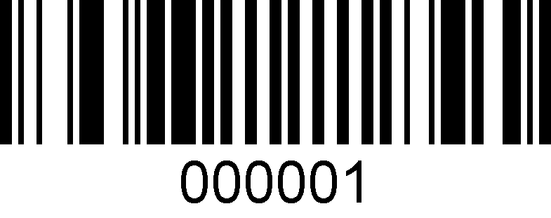

**Recall Default**

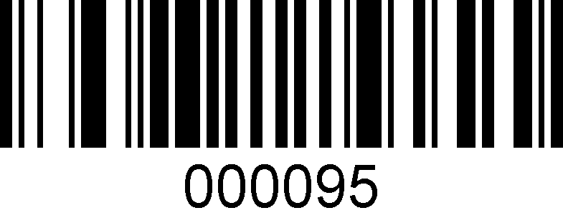

**Read the Version Number**

## Interface type setting

Identify the scanner as USB keyboard, should scan the "USB keyboard" bar code.

Under the environment of application software requiring serial port, USB can be recognized as USB COM type which requires user to install driver.

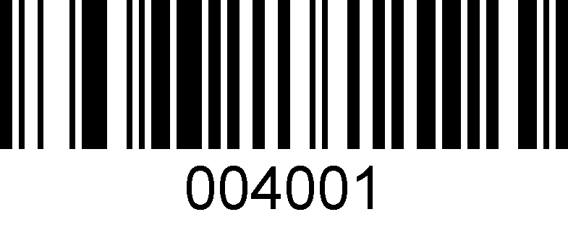

**USB Keyboard**

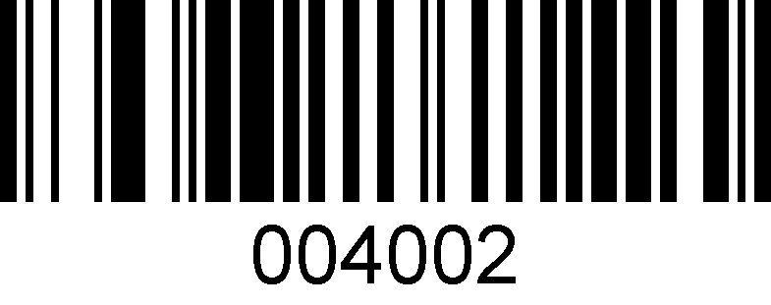

**USB COM**

# 2:Function mode setting

## About function mode setting

This chapter can configure the function mode of the device, including working mode (such as image brightness reverse, aimer setting, illumination configuration, LED indicator setting and speaker setting, etc.) You only need to scan the corresponding configuration code in turn according to the instructions.

## Working mode

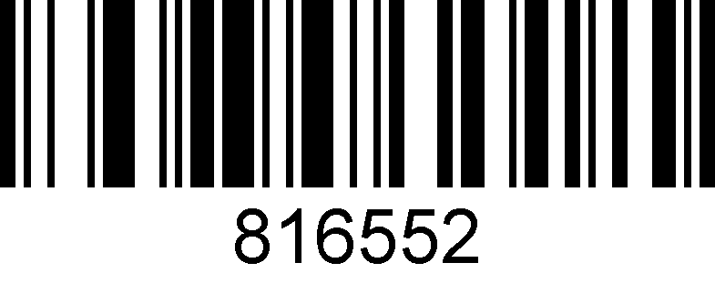

**\*Manual trigger mode**

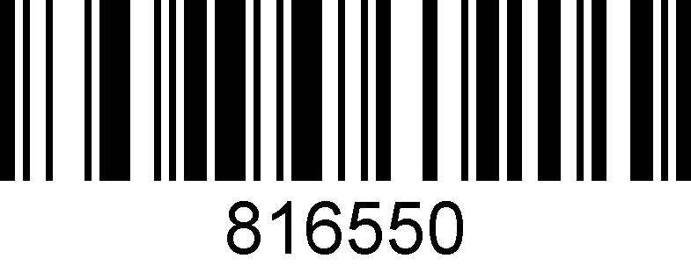

**Auto Scanning mode**

The sensitivity of automatic scanning mode is 15 levels, 1 is the highest and 15 is the lowest.

49859X，X represent the sensitivity grade（498591-4985915）

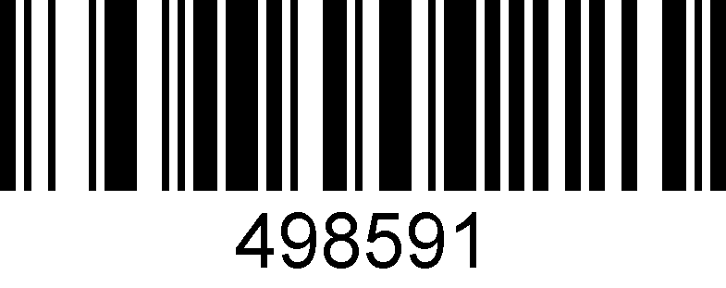

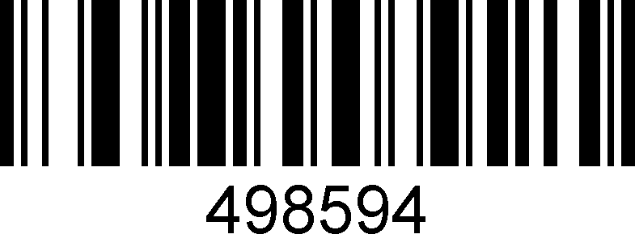

Same Bar Code Interval Time Settings in Auto Scanning Mode.

The same barcode interval time can be set to 1-127 (minimum 1, maximum 127)

When making configuration bar code, add "^ 3" character before it, such as ^ 37EFD6X (X means the same bar code interval time, 1 means 50ms, 127 means the same bar code interval time is 127 * 50ms),

Configuration barcode should be code 128 type.

81029X,（810291 -81029127）

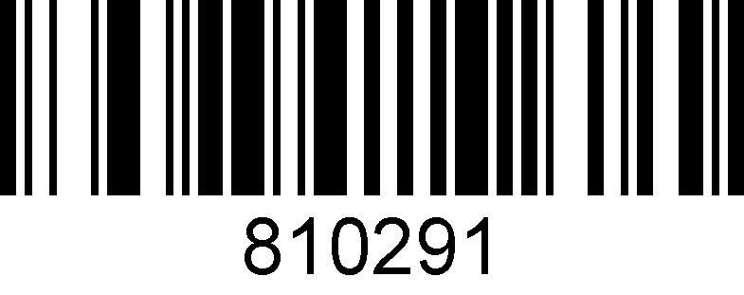

**50ms**

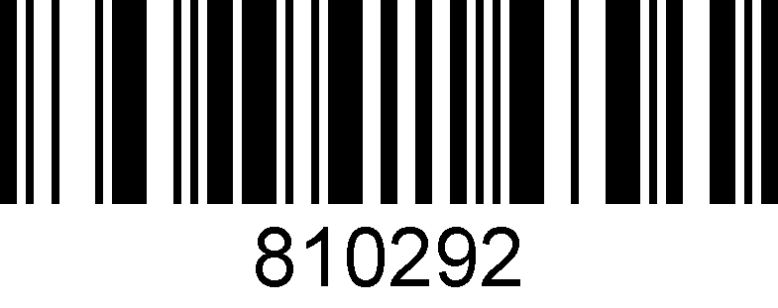

**100ms**

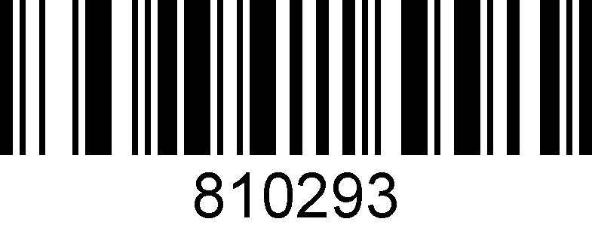

**150ms**

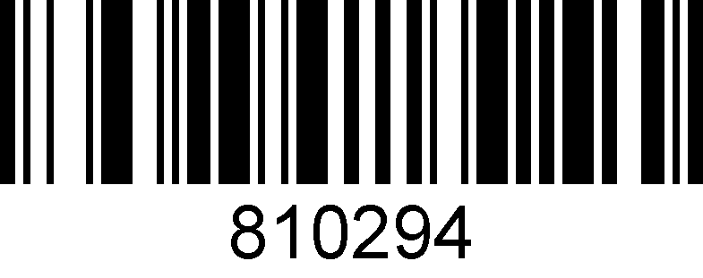

**200ms**

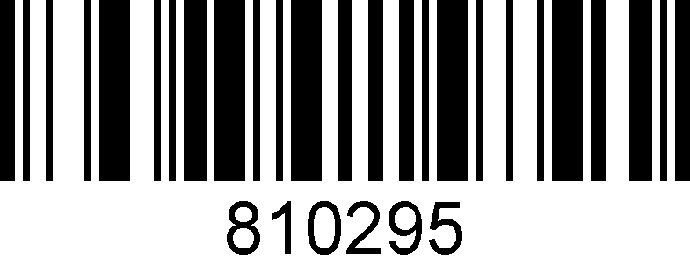

**250ms**

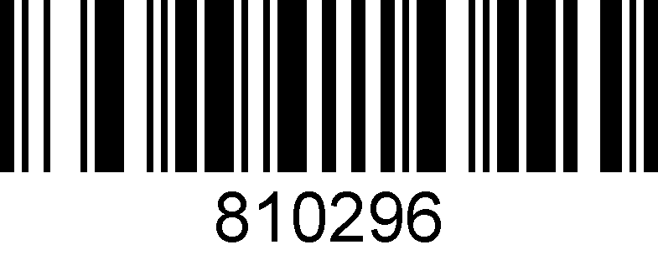

**300ms**

## Barcode type On/Off

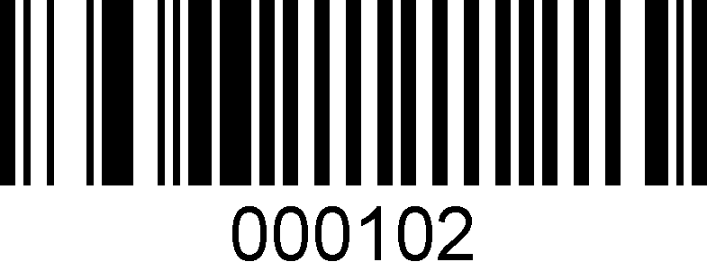

**All types On**

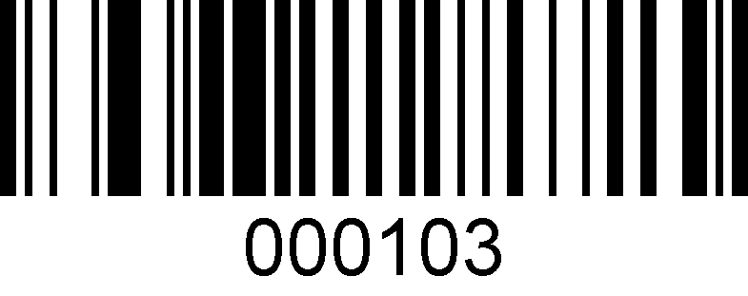

**All types Off**

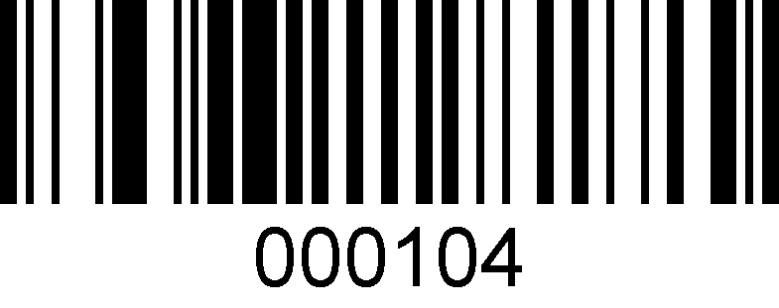

**All 1D barcode types On**

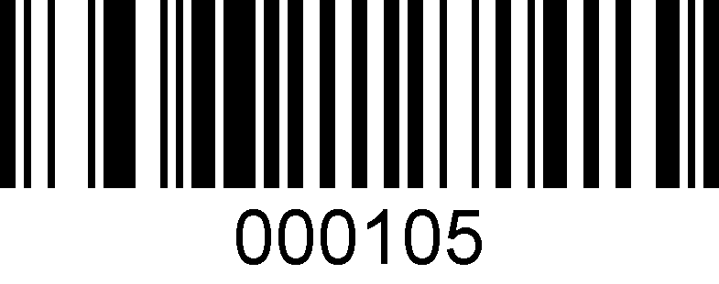

**All 1D barcode types Off**

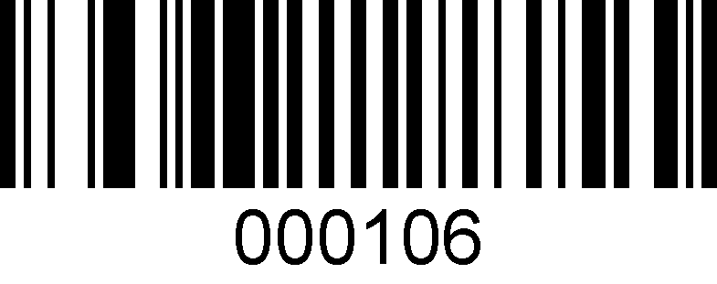

**All 2D barcode types On**

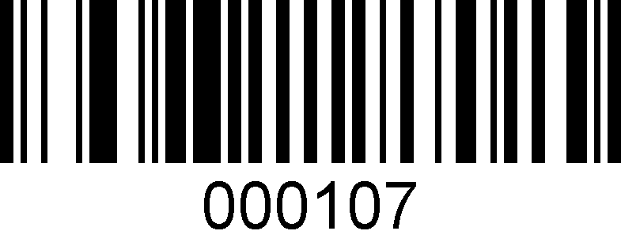

**All 2D barcode types Off**

## QR mirror image

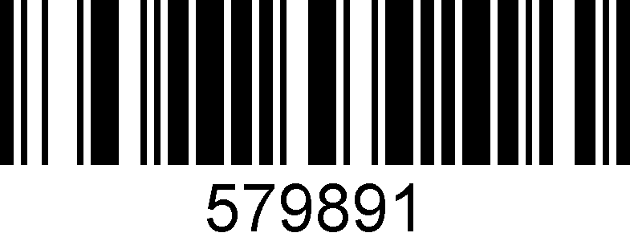

**Enable**

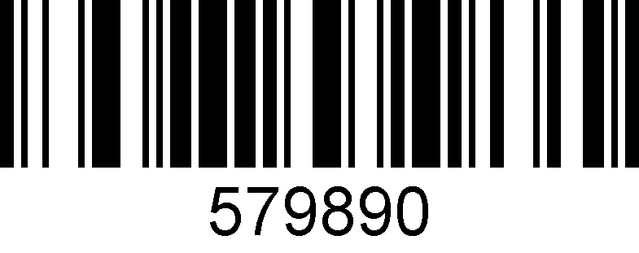

**\*disable**

## DATAMATRIX mirror image

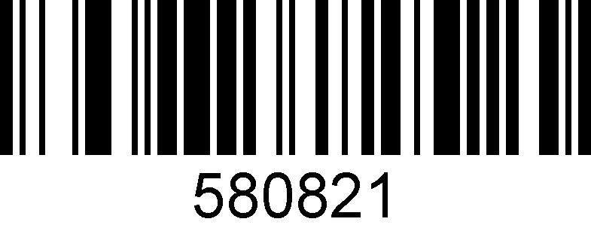

**Enable**

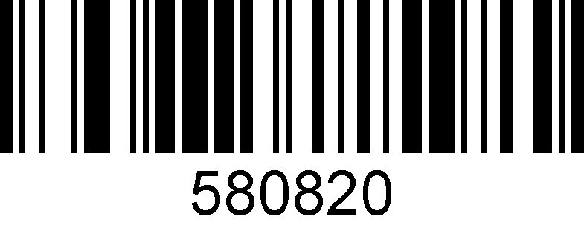

**\*disable**

## Mirror image for all types of barcode

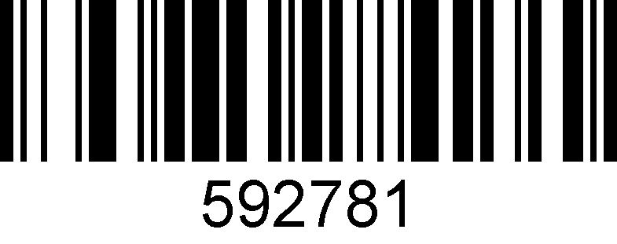

**Enable**

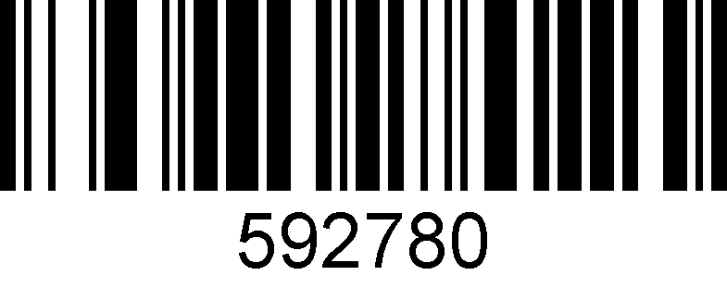

**\*Disable**

## Black and white reverse

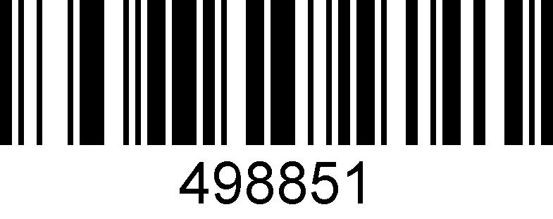

**Black & white reverse on**

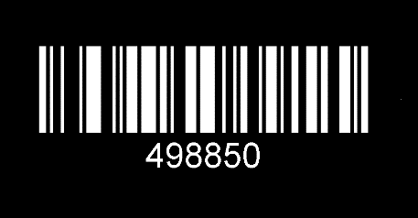

**\* Black & white reverse off**

## LED settings

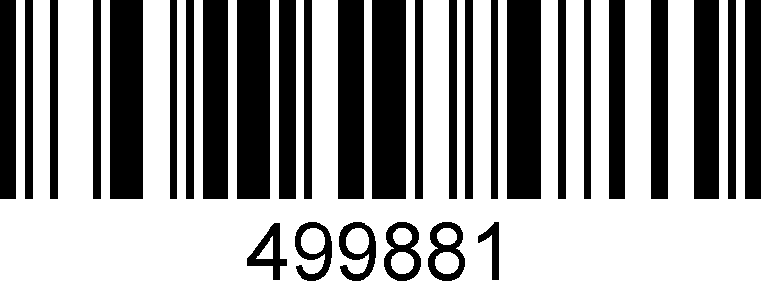

**\*Aimer enable**

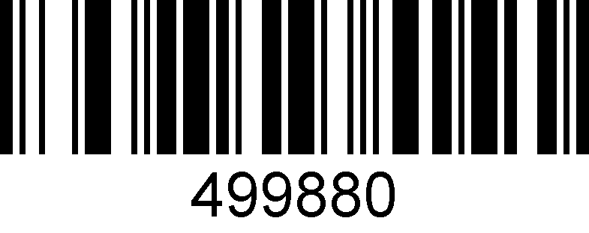

**Aimer disable**

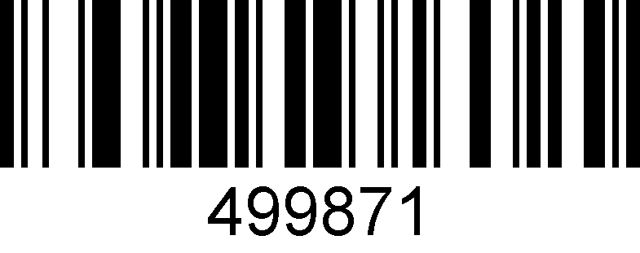

**\*Illumination enable**

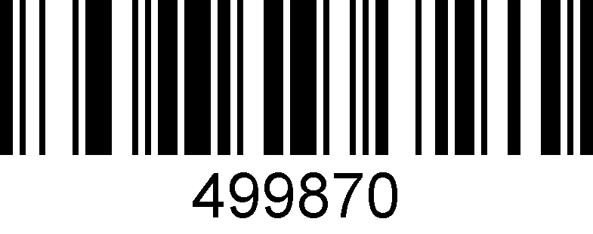

**Illumination disable**

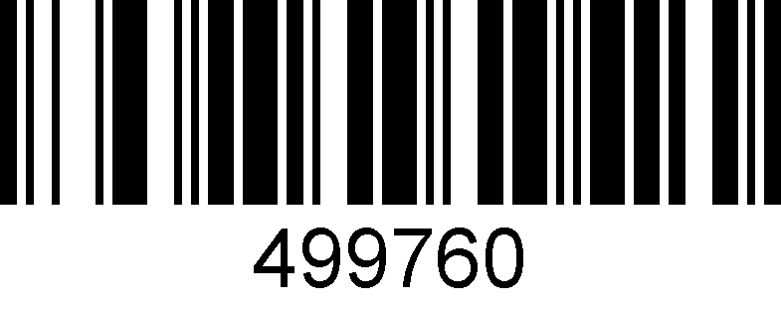

**\*Led indicator on**

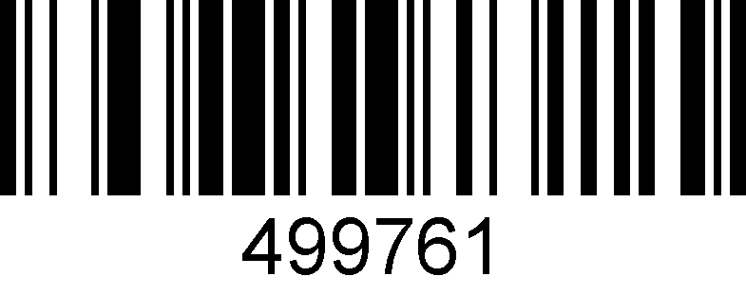

**Led indicator reverse**

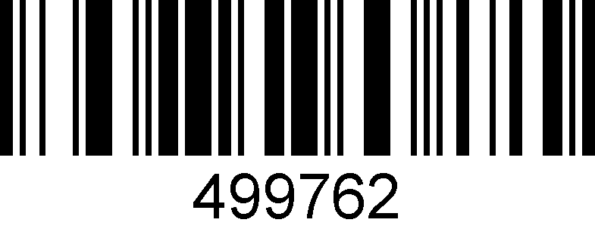

**Led indicator off**

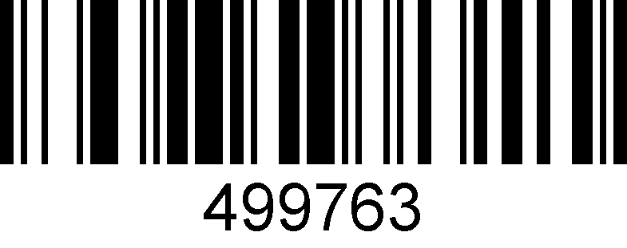

**Led indicator keep lighting up**

## Beeper setting

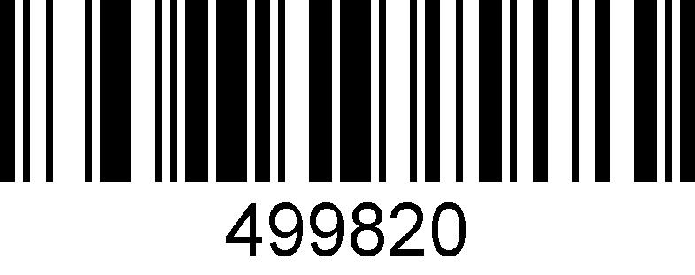

**\*Beeper on**

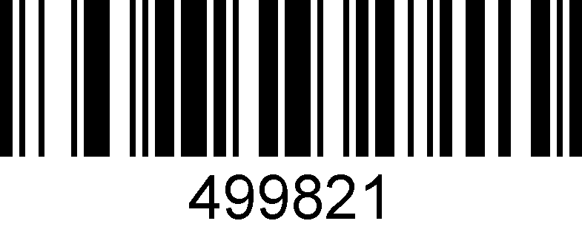

**Beeper off**

## Beeper duration

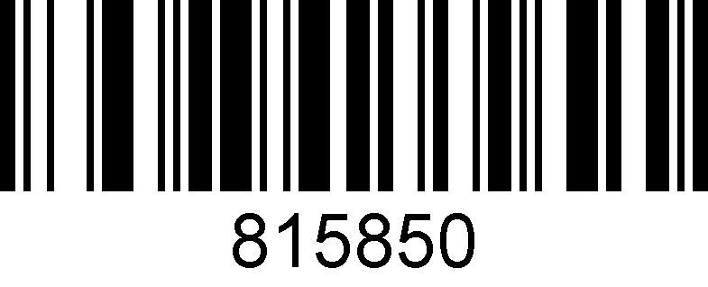

**Normal**

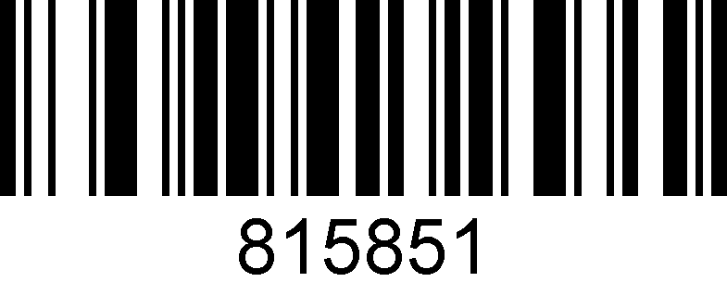

**Short**

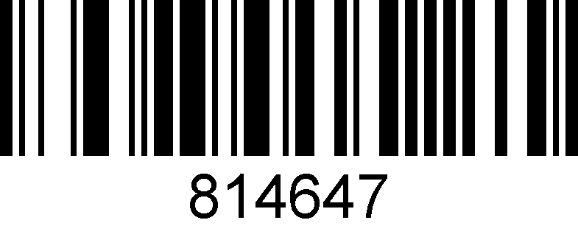

**2.7KHz**

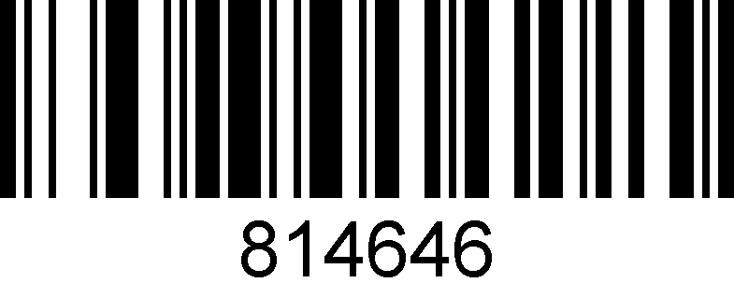

**1.6KHz**

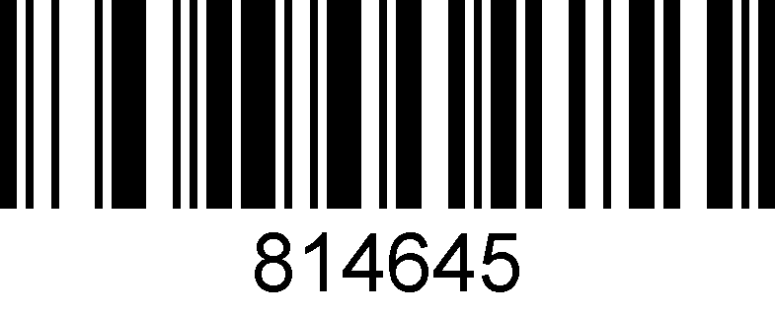

**2.0KHz**

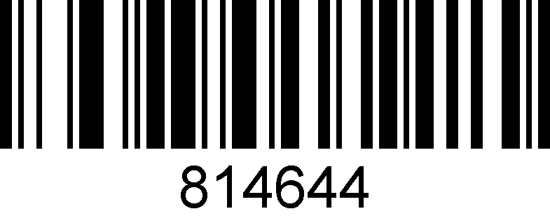

**2.4KHz**

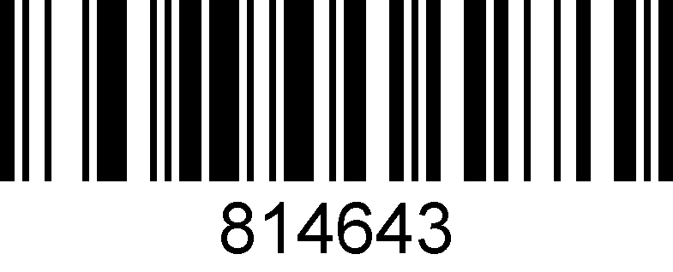

**3.1KHz**

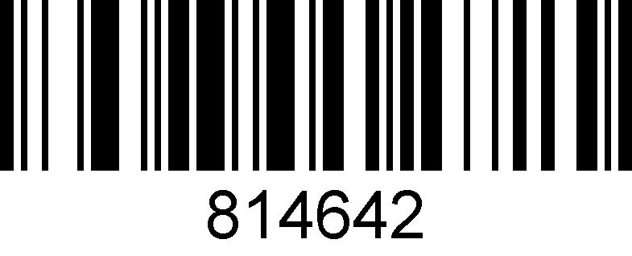

**3.5KHz**

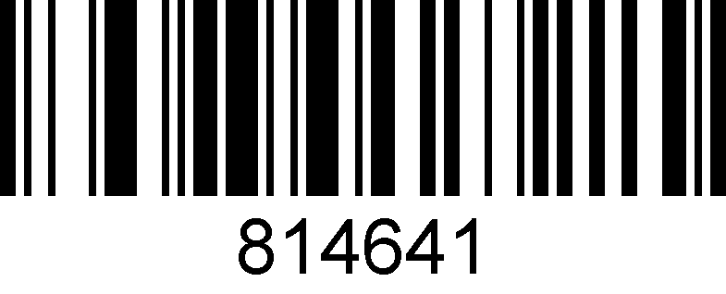

**4.2KHz**

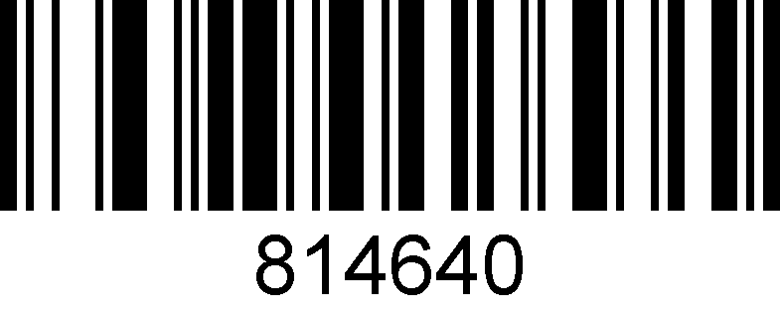

**No Beep**

## Testing mode

Once configured in blink test mode, the device automatically triggers decoding every second.

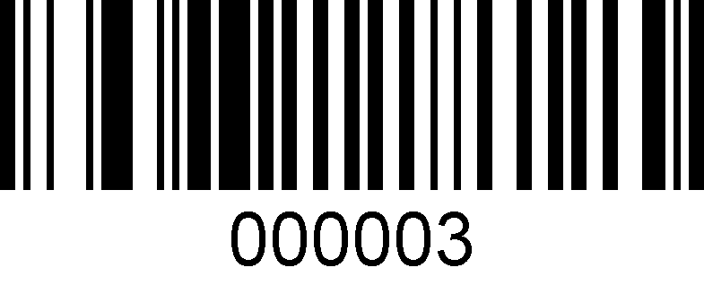

**blink test mode on**

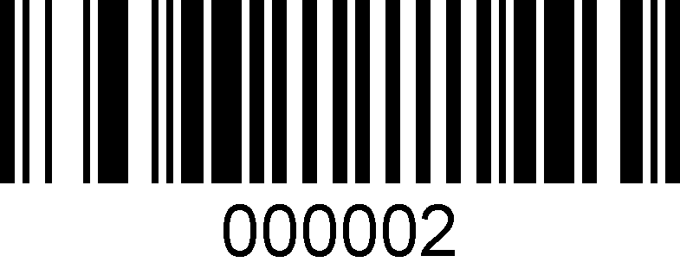

**\*blink test mode off**

## Standby mode setting

When making configuration barcode, add "^ 3" character before the digital command, such as ^352419X (X means standby time), and the configuration barcode should be code128 type.

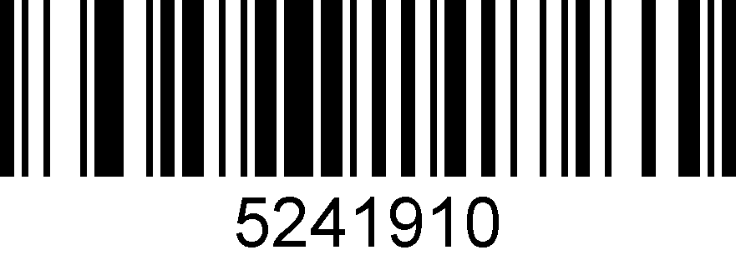

**10s**

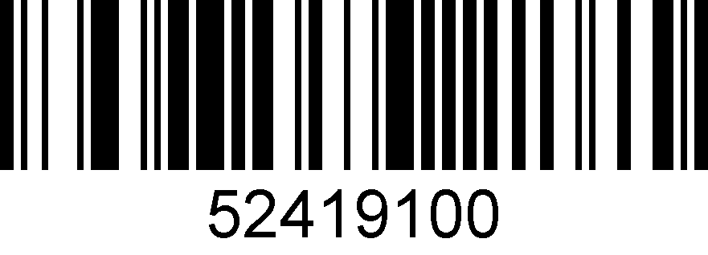

**100s**

## Multi-level illumination setting

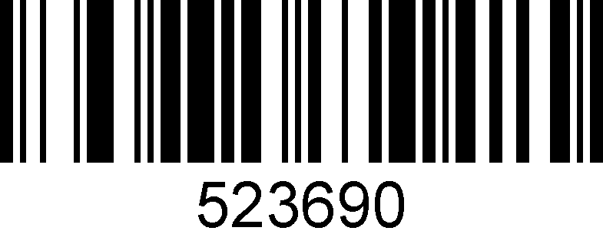

**Level 1**

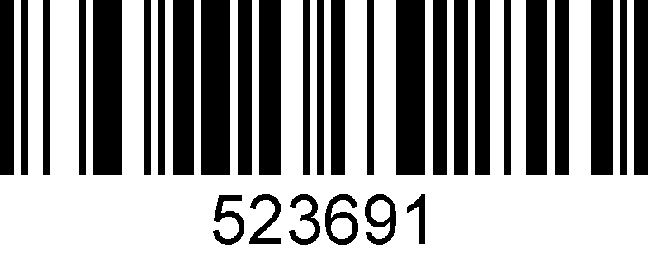

**Level 2**

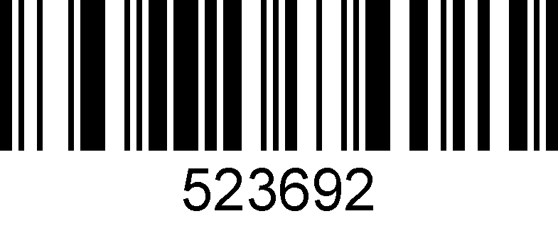

**Level 3**

## Timeout setting

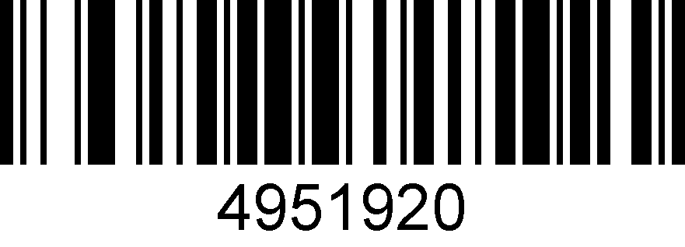

**30s**

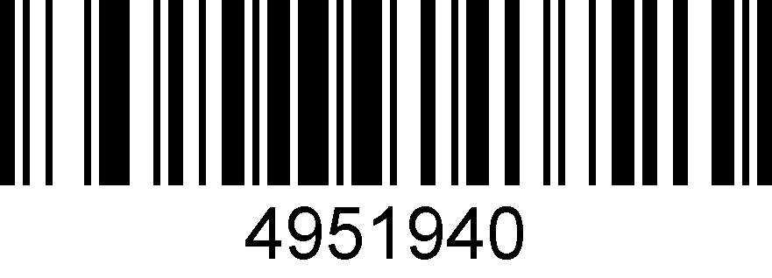

**60s**

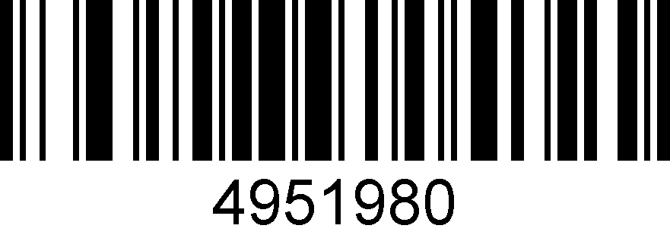

**120s**

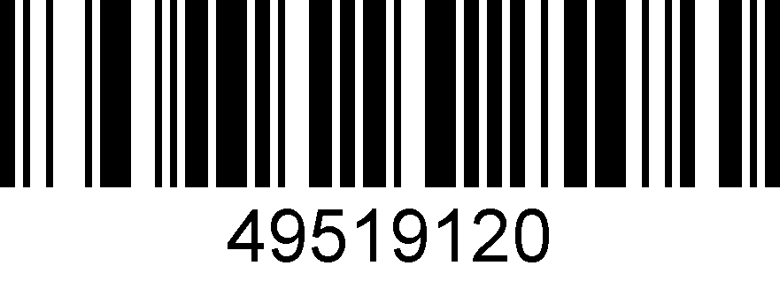

**180s**

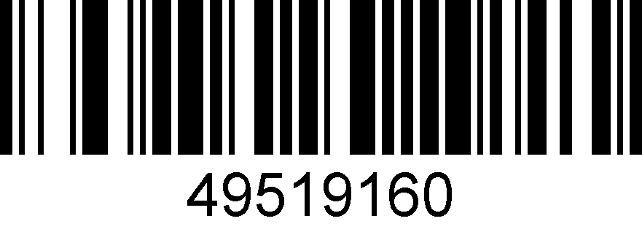

**240s**

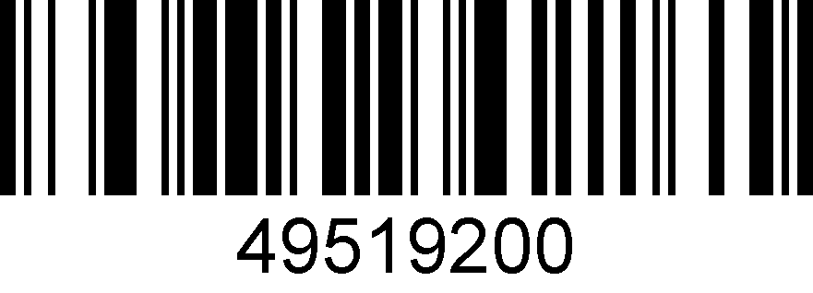

**300s**

## Interface setting

### RS232 interface

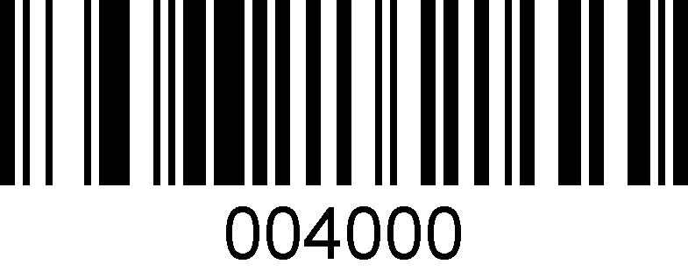

### RS232 baud rate

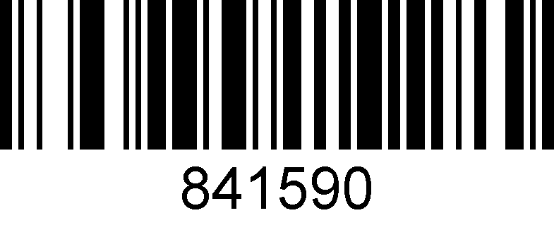

**300**

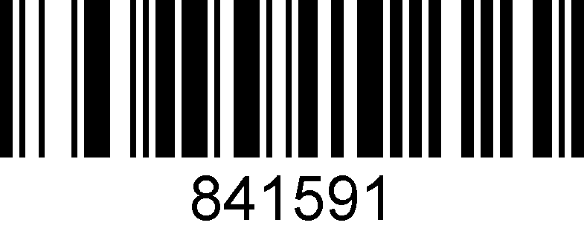

**600**

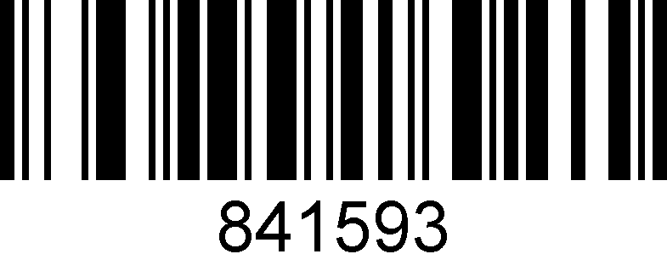

**2400**

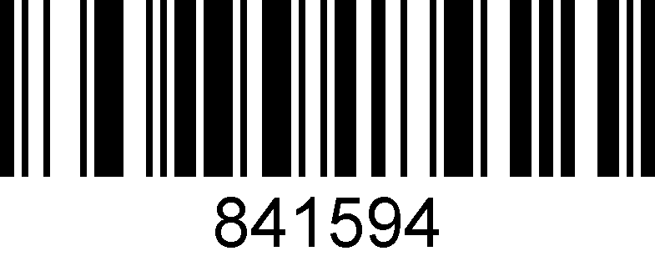

**4800**

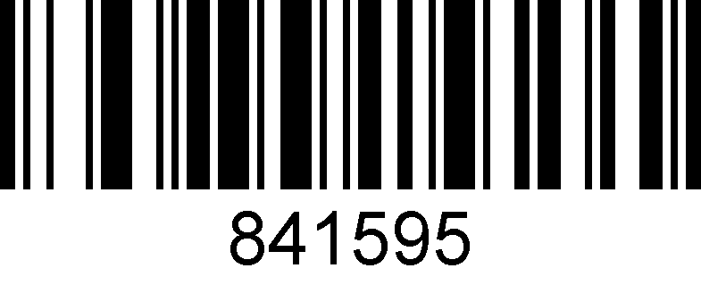

**9600**

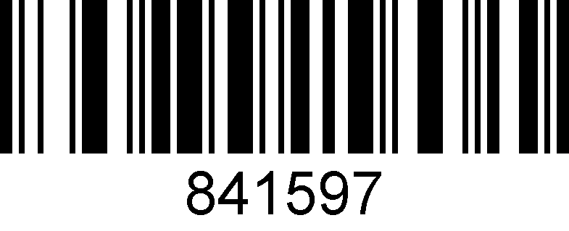

**19200**

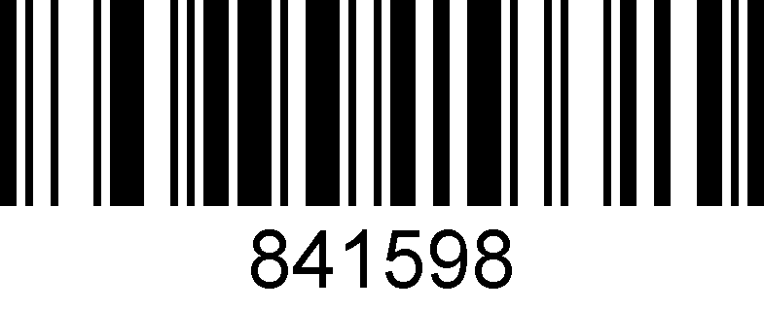

**38400**

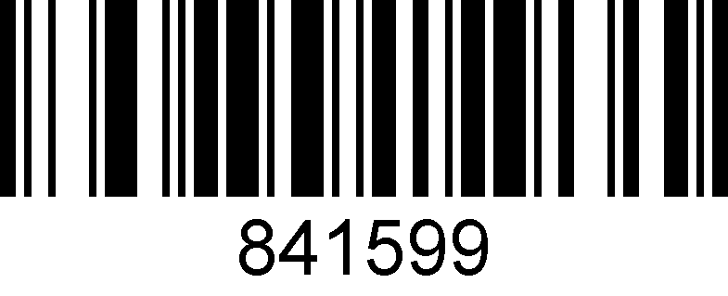

**57600**

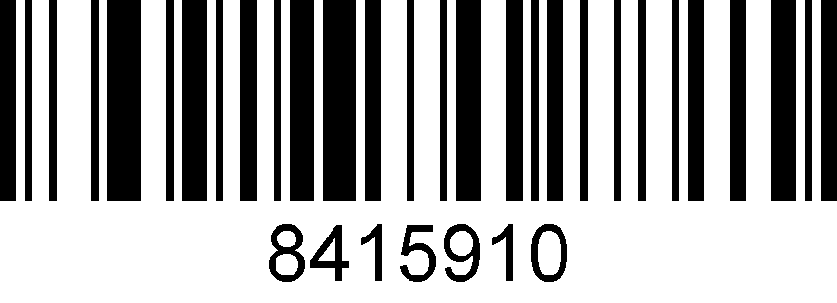

**115200**

### Data bits

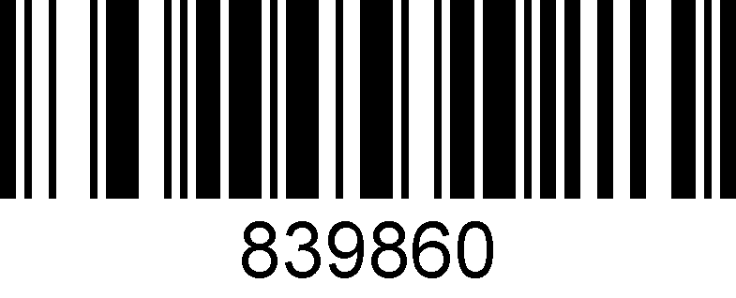

1. **bits**

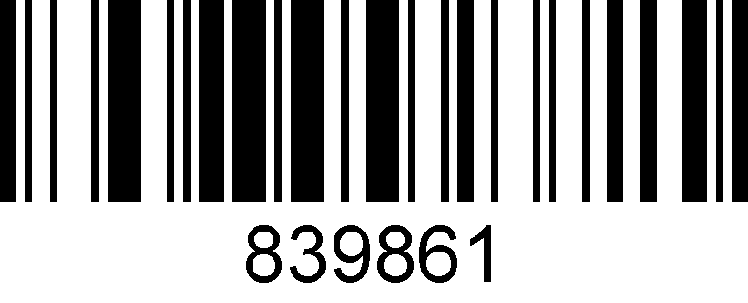

**8 bits**

### Stop bits

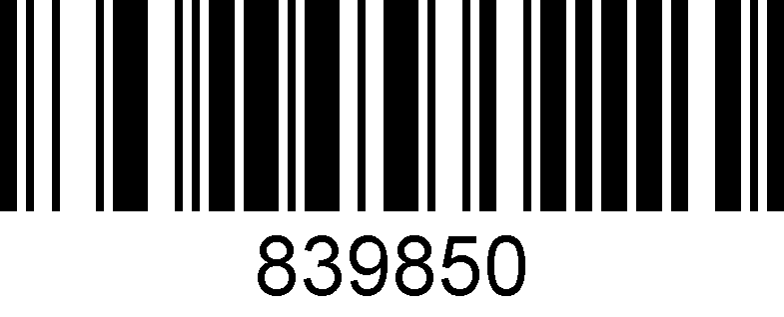

**2 bits**

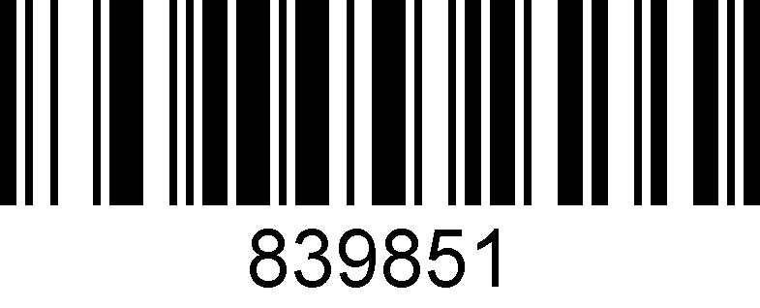

**1 bit**

### Check bit setting

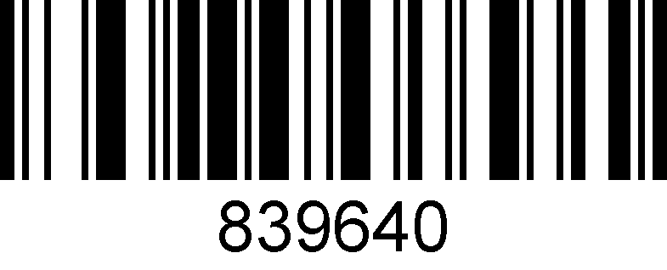

**O**

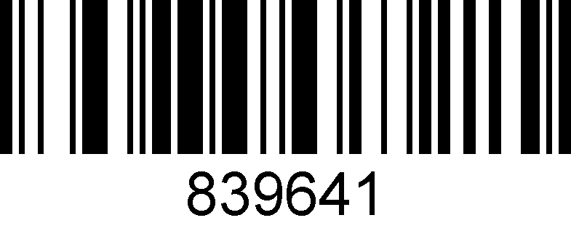

**S**

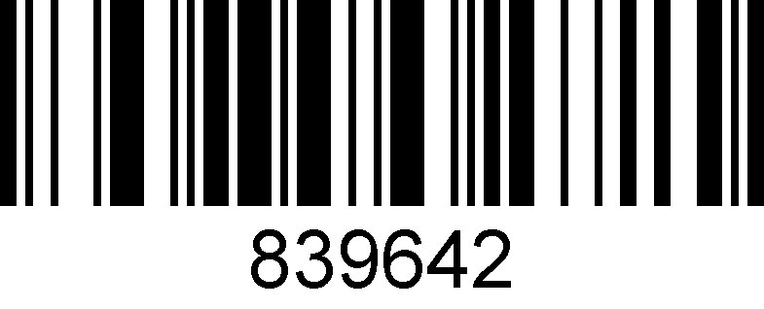

**E**

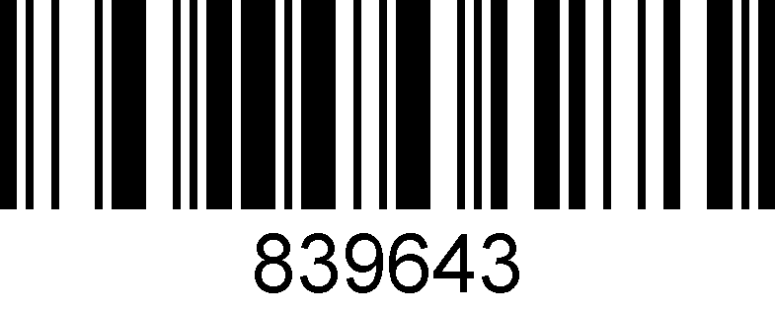

**M**

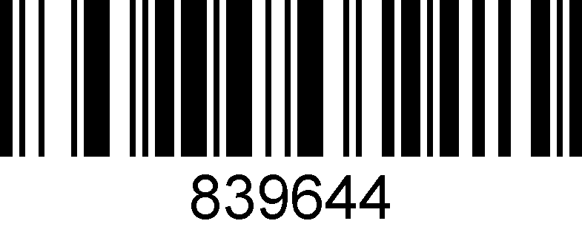

**N**

# 3:Output setting

## About output setting

This chapter can configure the output of the barcode scanner, including carriage return/line feed, adding prefix/suffix, setting bar code length, removing barcode digits (start/end removal) and multi-national keyboard switching settings.

You only need to scan the corresponding configuration codes in turn according to the instruction.

## Carriage return/Line feed setting

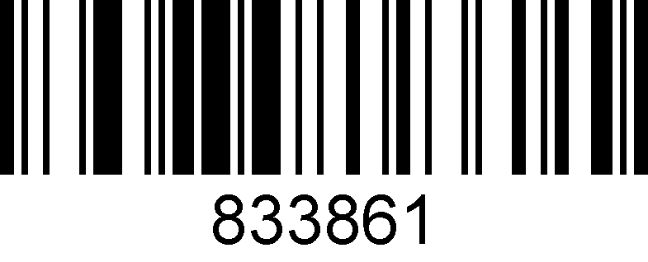

**Add carriage return**

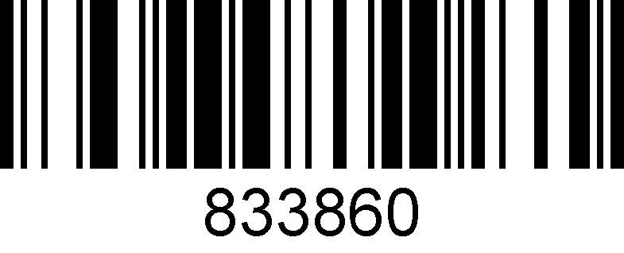

**Remove carriage return**

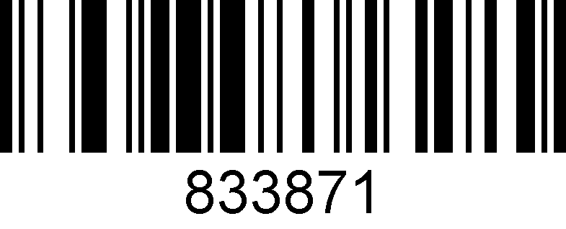

**Add line feed**

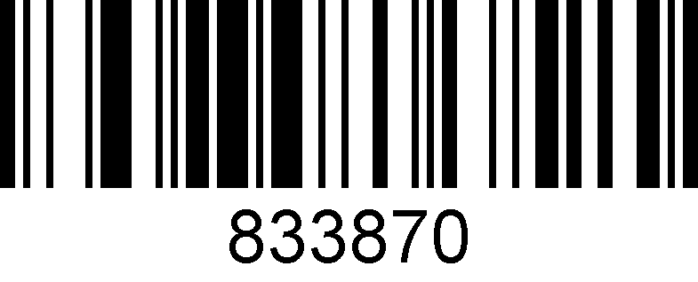

**Remove Line feed**

## Remove digits setting

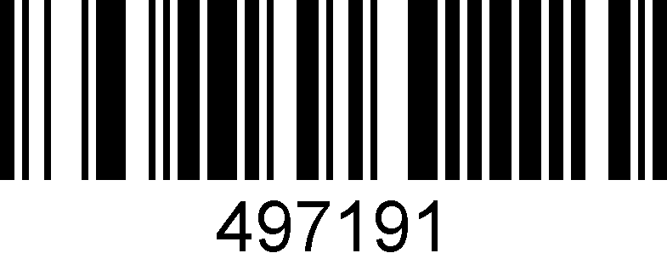

**Remove from start**

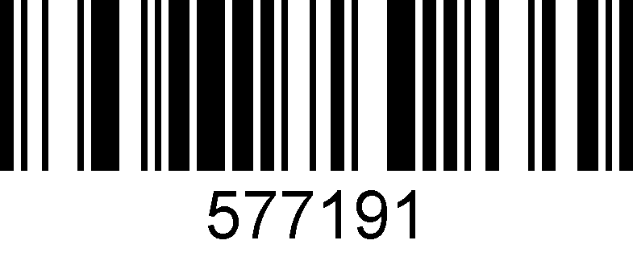

**Remove from end**

Remove the number of digits (the last number of setting barcode represents the number of digits user wants to remove)



**^349719X（X represents the numbers of digits should be removed）**

## Barcode length setting

The length of barcode could be set from 1 to 255 (minimum length is 1 and maximum length is 255).

When making configuration barcode, add "^ 3" character before the digit command, such as ^398119X (X indicates the length of bar code), the configuration barcode should be code128 type.

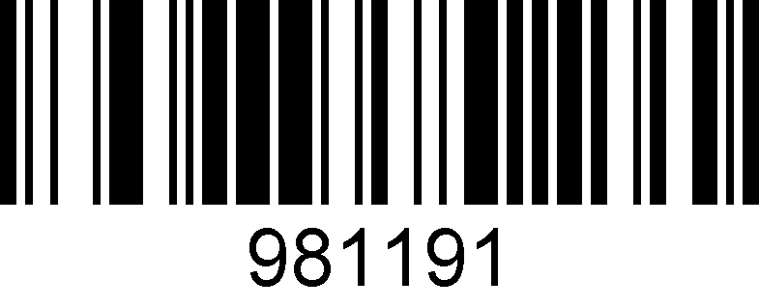

**Length 1**

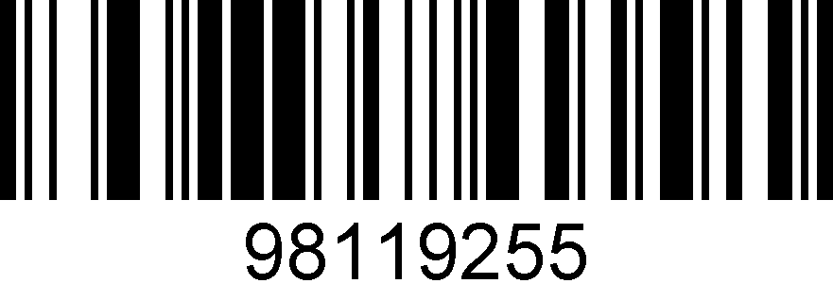

**Length 255**

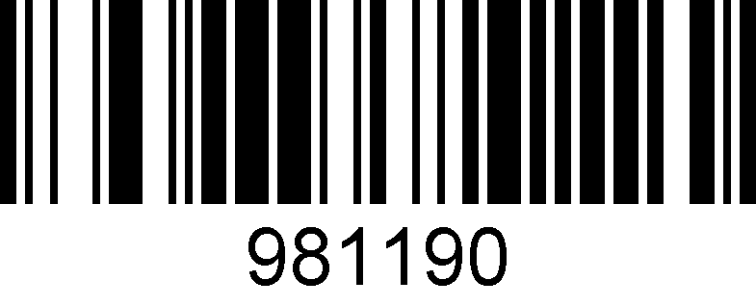

**Barcode length lock**

## Add-on code setting

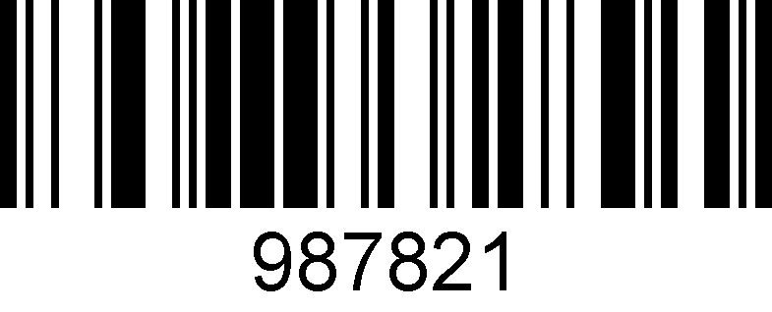

**Enable 2 digits add-on code**

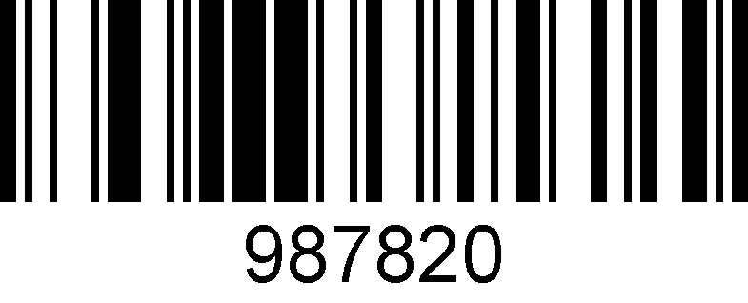

**\* Disable 2 digits add-on code**

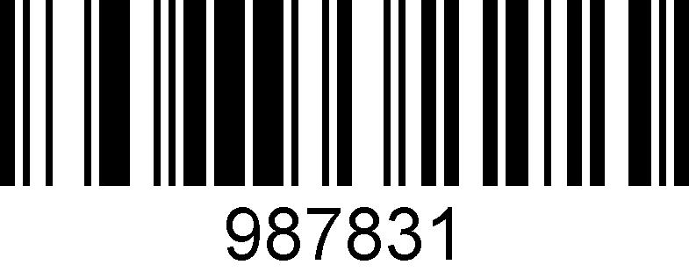

**Enable 5 digits add-on code**

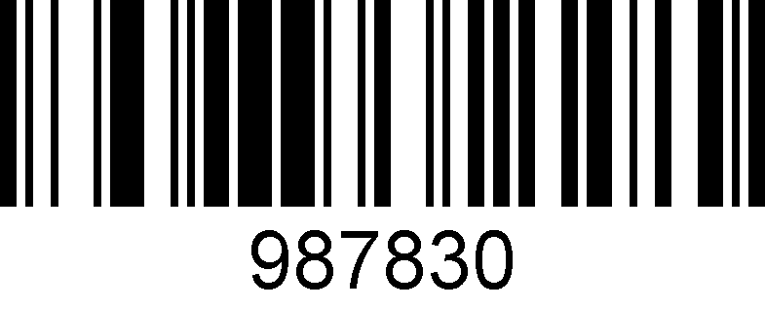

**\* Disable 5 digits add-on code**

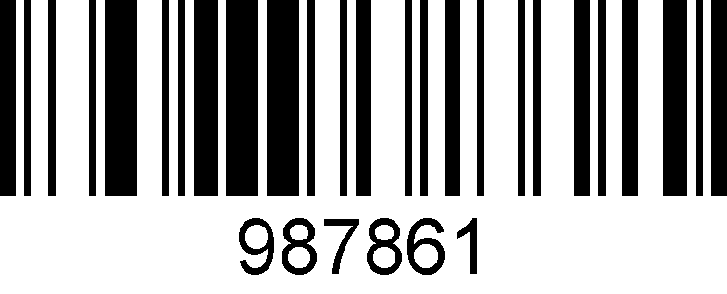

**Add-on code must have(UPC/EAN)**

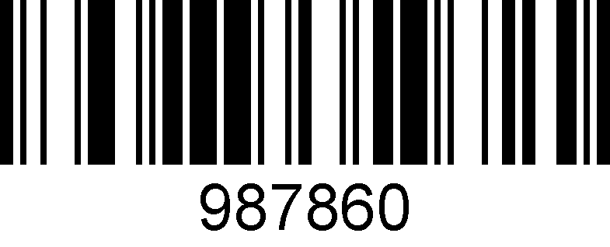

**\* Add-on code must have off (UPC/EAN)**

## Chinese output setting for USB keyboard mode

USB keyboard mode could output Chinese Characters, scan the corresponding configuration code as below to set the Chinese output. (The default status is no Chinese, and can be swiched into other languages)

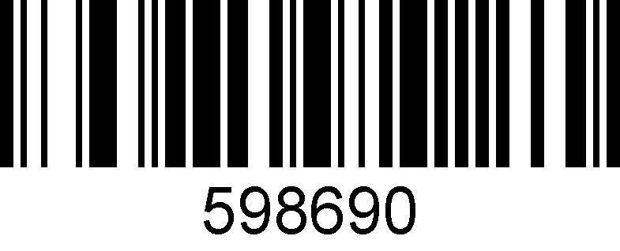

**\*Default**

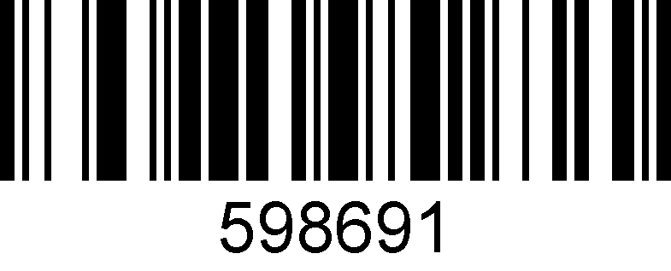

**For MS Word, QQ，Not for MS Excel, MS Notebook**

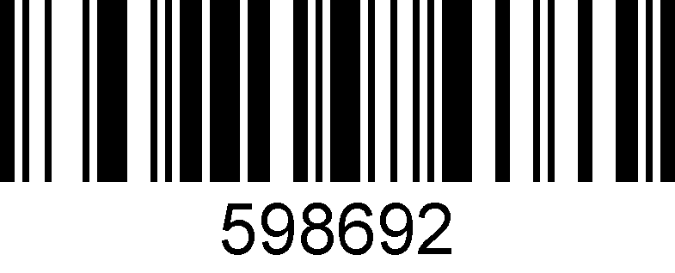

**For MS Excel, MS Notebook，Not for MS Word, QQ**

## Keyboard language setting

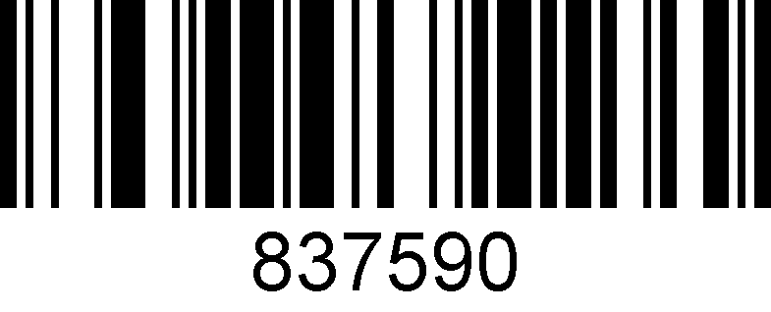

**Belgium**

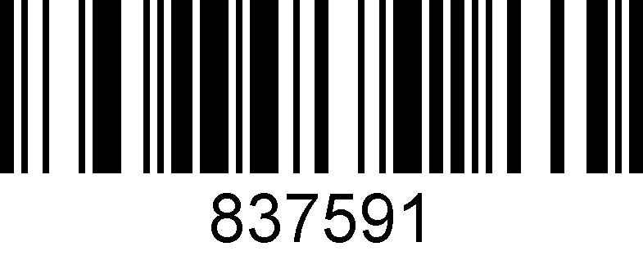

**British**

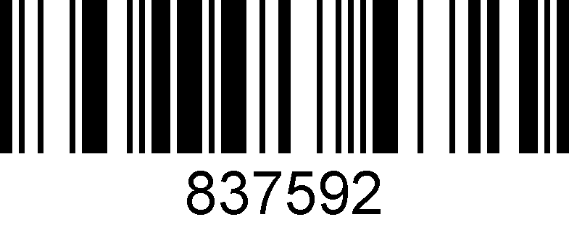

**France**

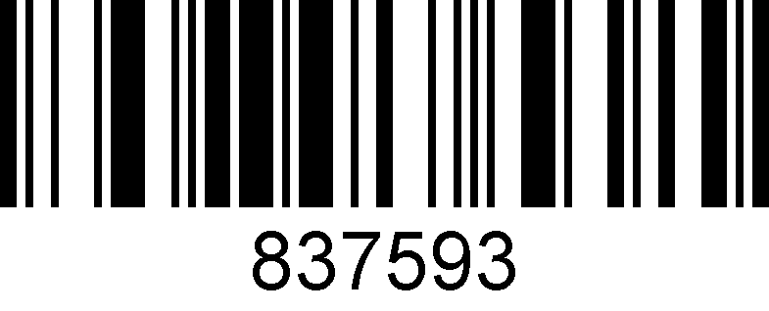

**Germany**

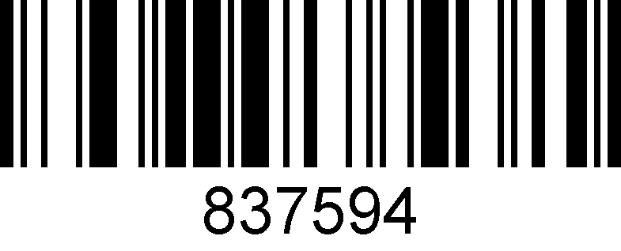

**Italy**

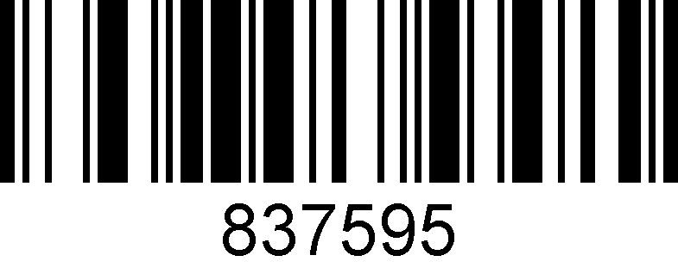

**Spain**

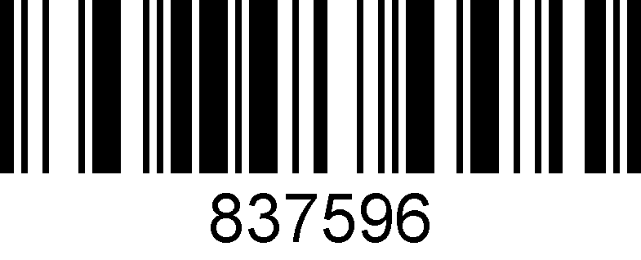

**USA**

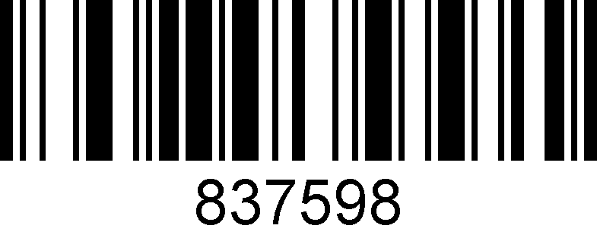

**Singapore**

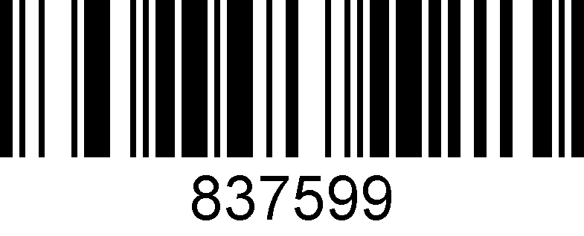

**Salvatore**

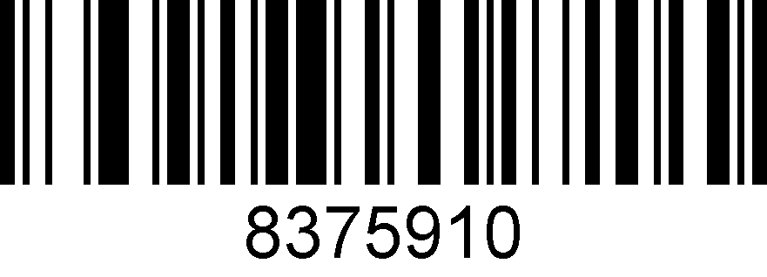

**Japan**

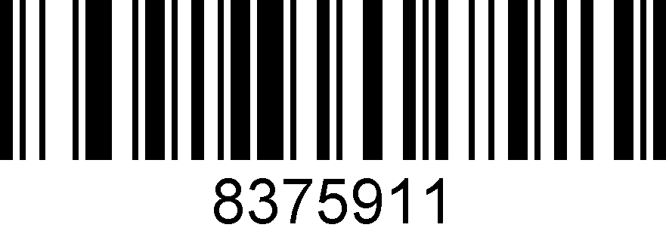

**Sierra Leone**

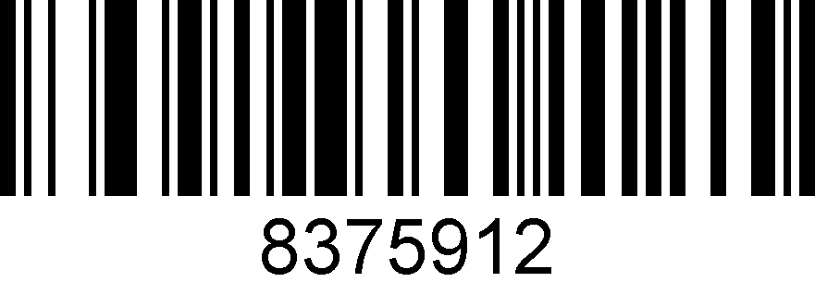

**Turkey**

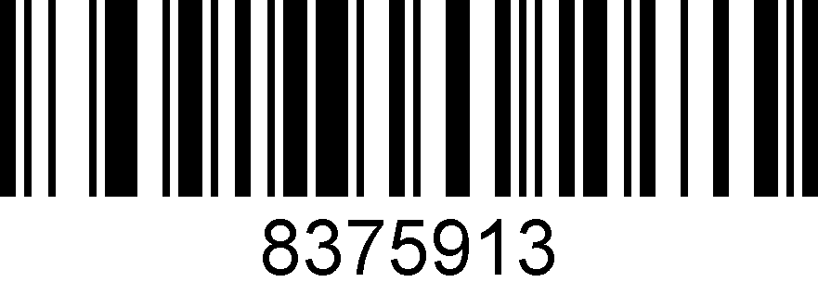

**Russia**

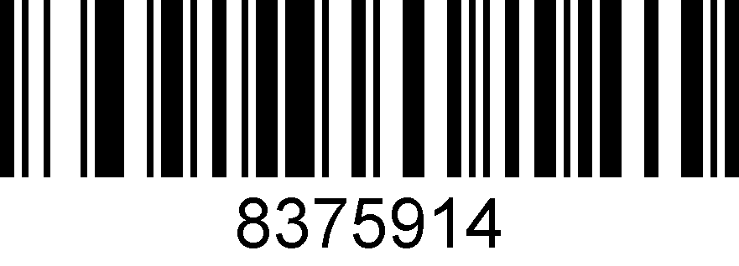

**Hungary**

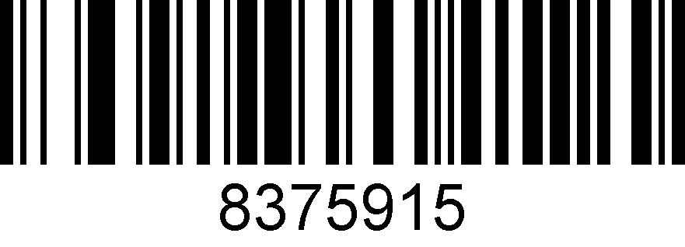

**Russian (Russia)**

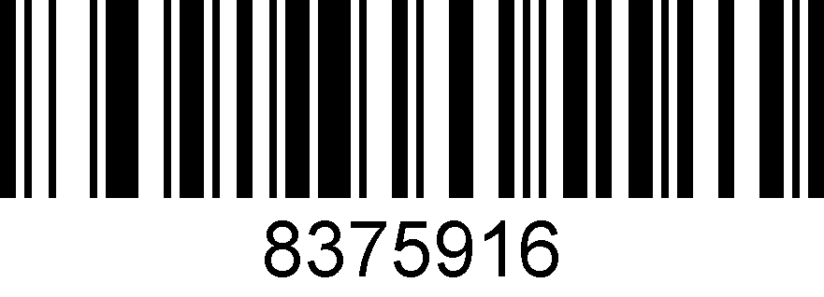

**Thailand**

## ASCII alt code setting

You may need to output the characters in the form of ASCII code, at which time you could configure the corresponding configuration code as instruction.

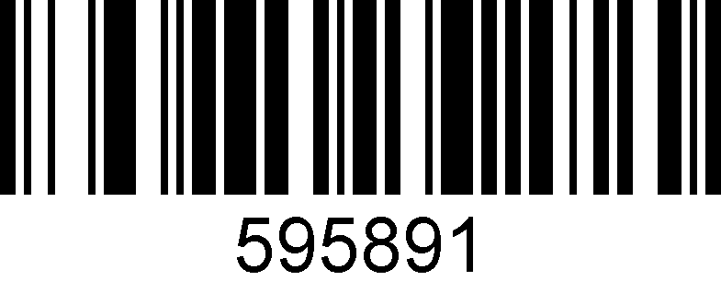

**Alt code mode on**

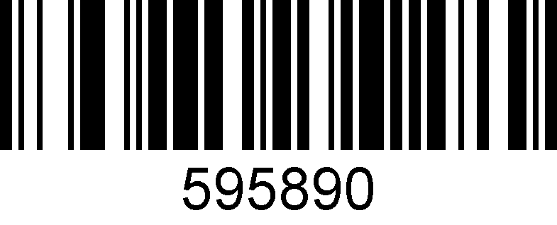

**Alt code mode off**

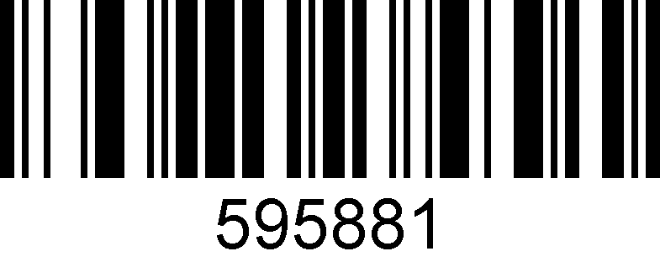

**4 digits alt code on**

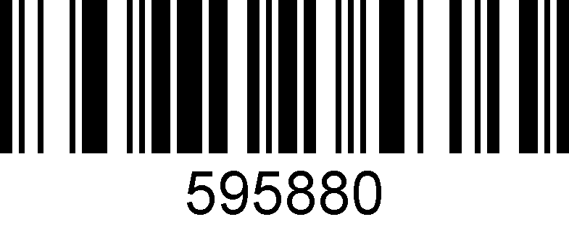

**4 digits alt code off**

## Case switching

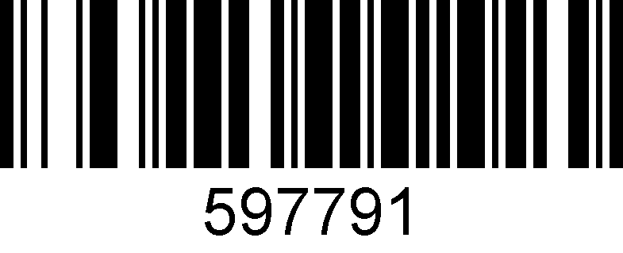

**All lower case**

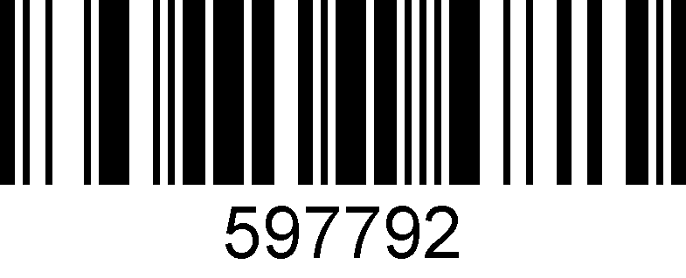

**All higher case**

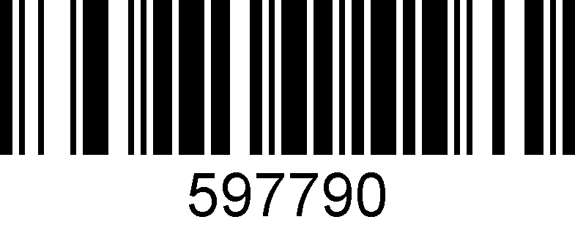

**Default case setting**

# 4: Barcode types setting

## About barcode types

This chapter is about the configuration of barcode types for scanners, including UPC/EAN, Codabar code, Code39, Full ASCII Code39, Interleaved 2 of 5, Code93, UPC-A, GS1 DataBar Omnidirectional, GS1 DataBar Expanded, PDF 117, QR Code, Hong 2 of 5 (post) and Airline 2 of 5 and other supporting bar code configurations, scan the corresponding configuration barcode in turn according to the instructions. All barcodes marked with (*) denote default factory settings.

## Barcode types setting

### 1. Airline 2 of 5

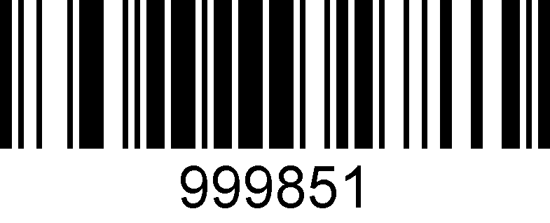

**Enable**

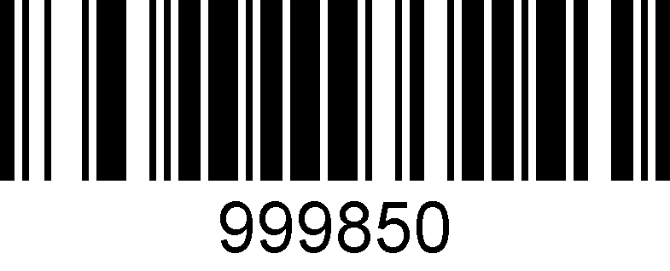

**\*Disable**

### 2. Aztec Code

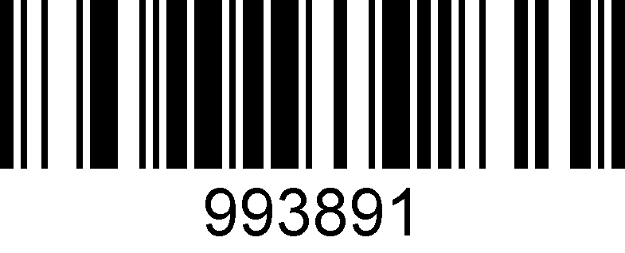

**Enable**

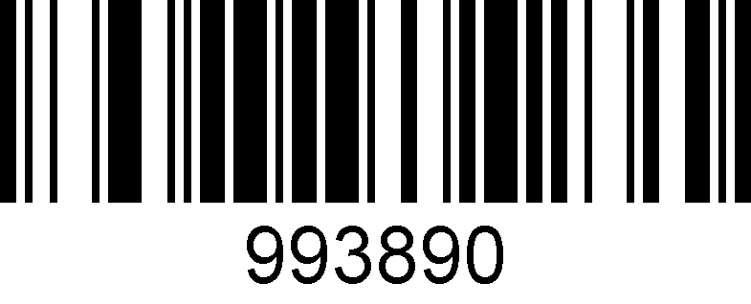

**\*Disable**

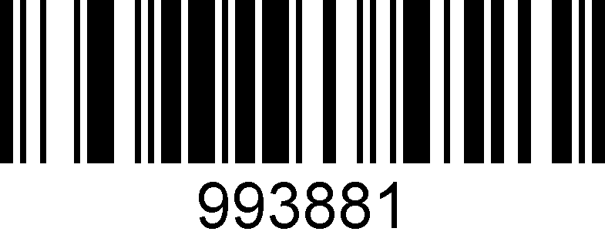

**Black & White reversed Aztec enable**

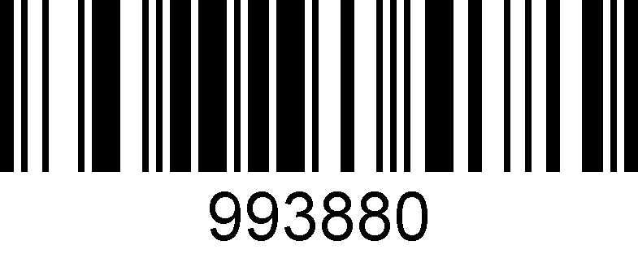

**\* Black & White reversed Aztec disable**

### 3. Codabar

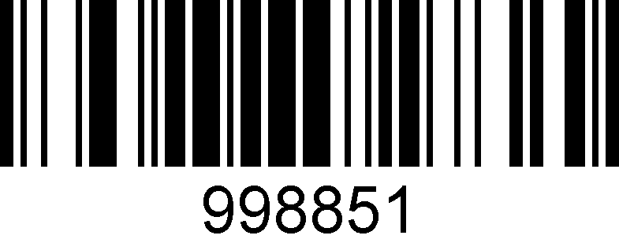

**\*Enable**

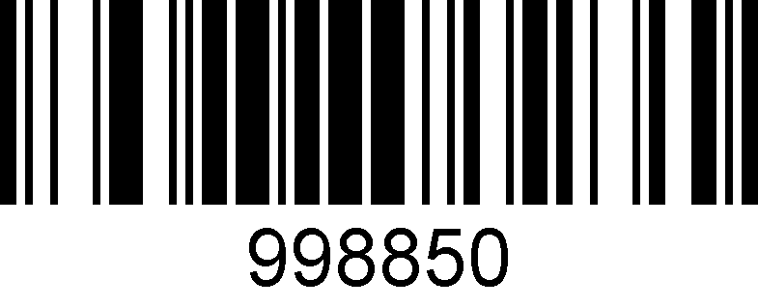

**Disable**

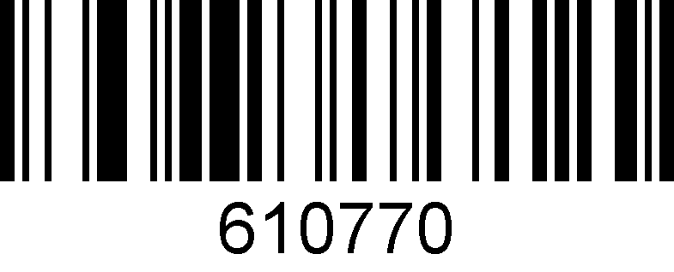

**\*No Check bit**

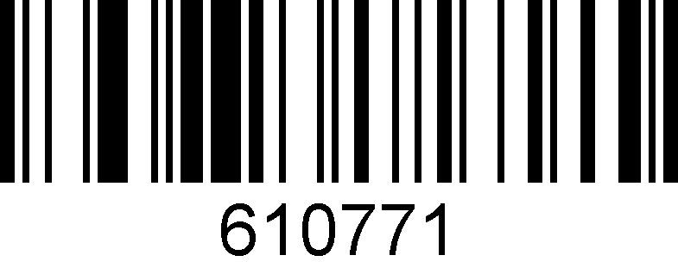

**Open check bit**

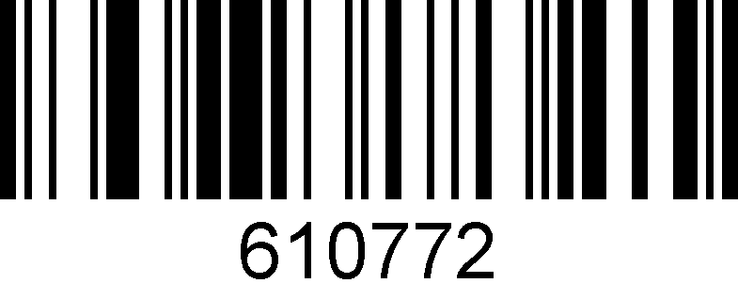

**Open and output the check bit**

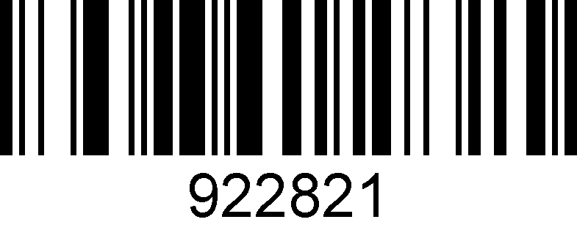

**Initial and ending characters output on**

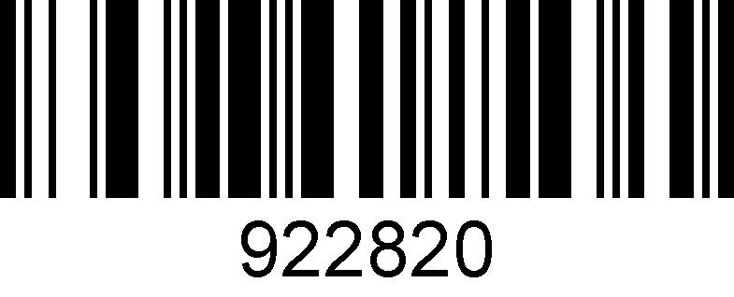

**\* Initial and ending bits output off**

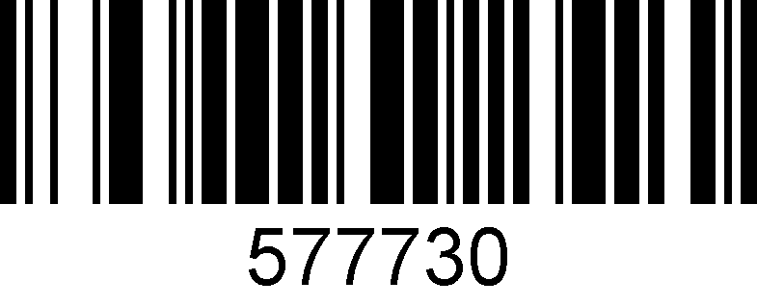

**No read Black&White reverse code**

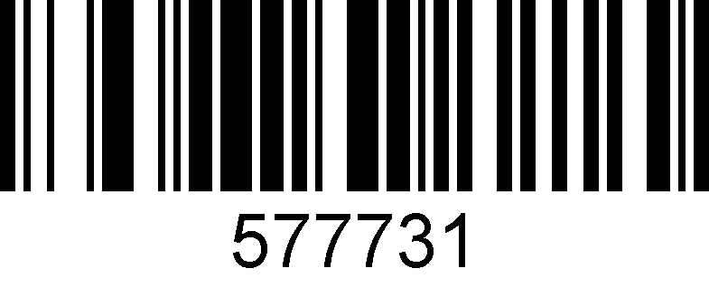

**Read the Black&White reverse code**

### 4. Codablock A

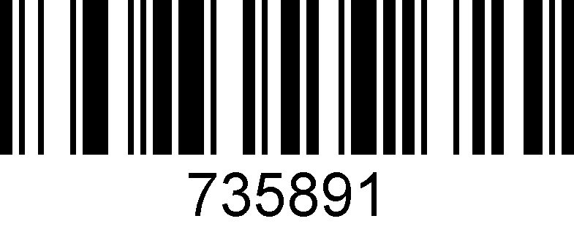

**Enable**

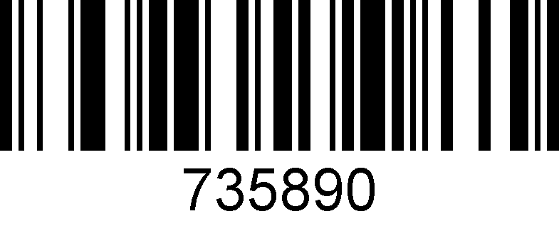

**\*Disable**

### 5. Codablock F

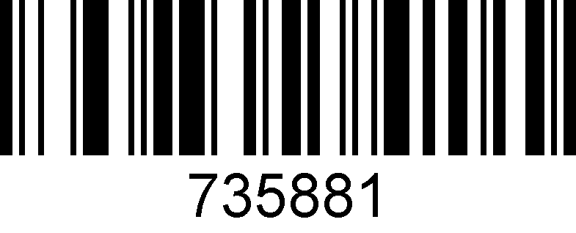

**Enable**

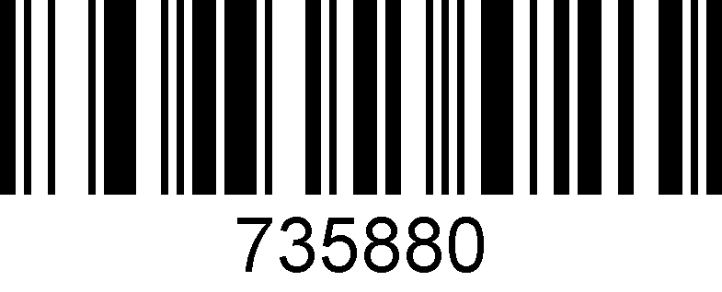

**\*Disable**

### 6. Code 128

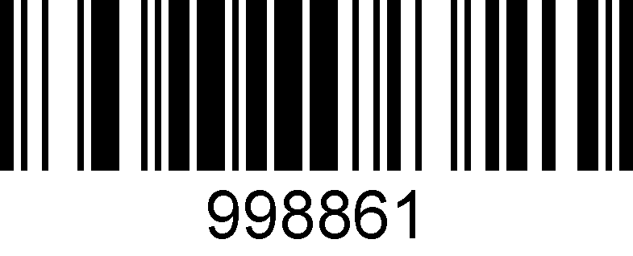

**\*Enable**

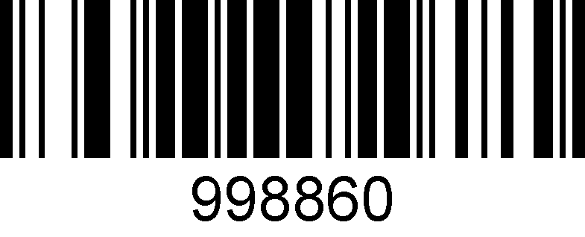

**Disable**

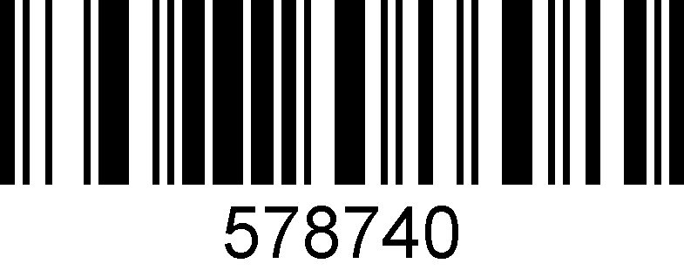

**No read Black&White reverse code**

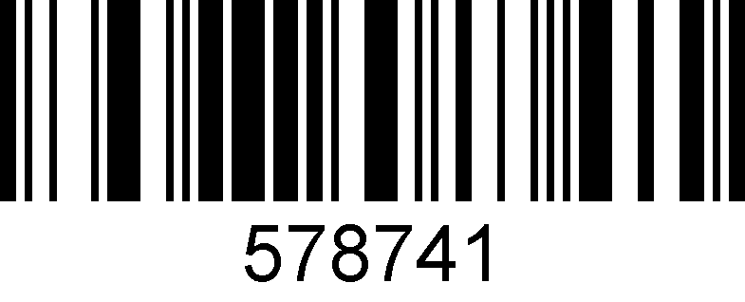

**Read the Black&White reverse code**

### 7. Code 11

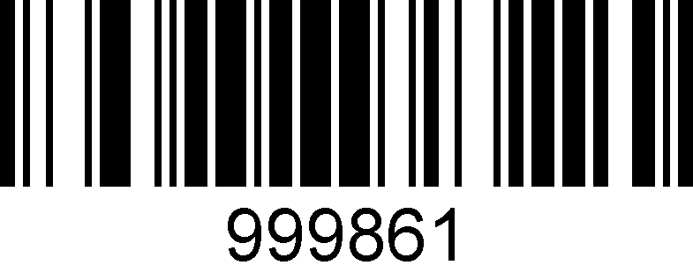

**Enable**

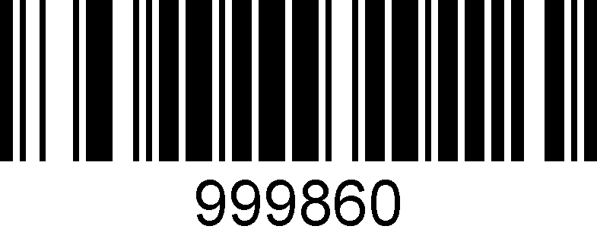

**\*Disable**

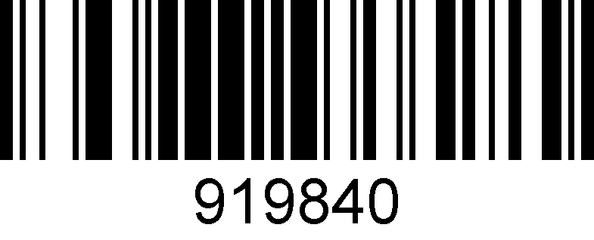

**\*1 check bit**

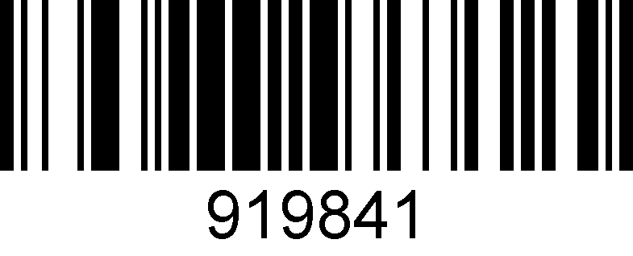

**2 check bits**

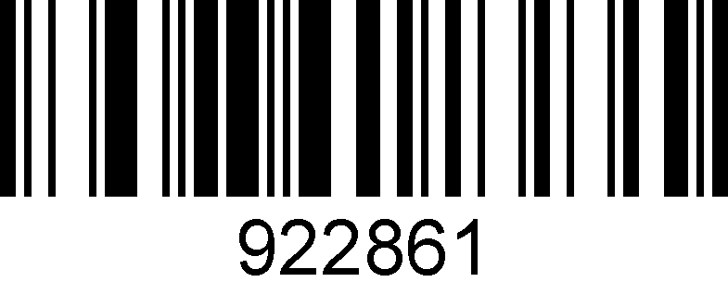

**Check bits output**

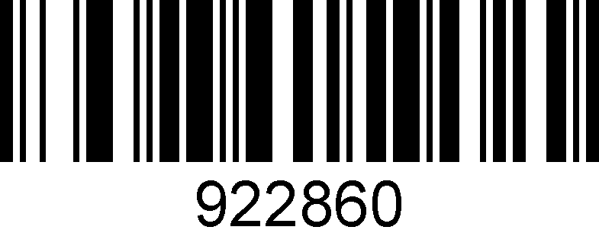

**\* Check bits output off**

### 8. Code 32

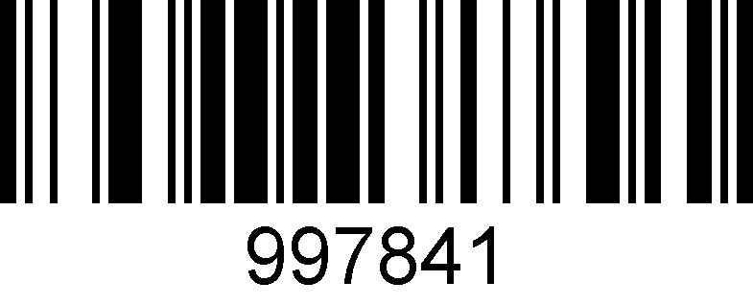

**Enable**

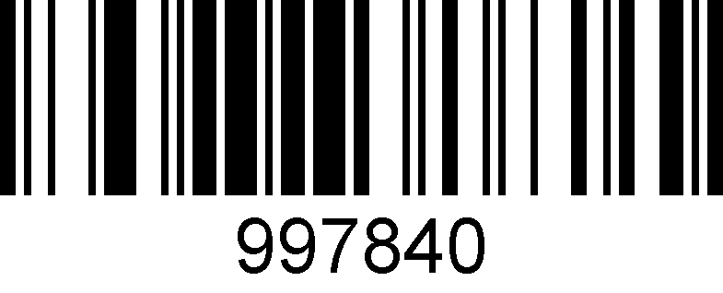

**\*Disable**

### 9. Code 39

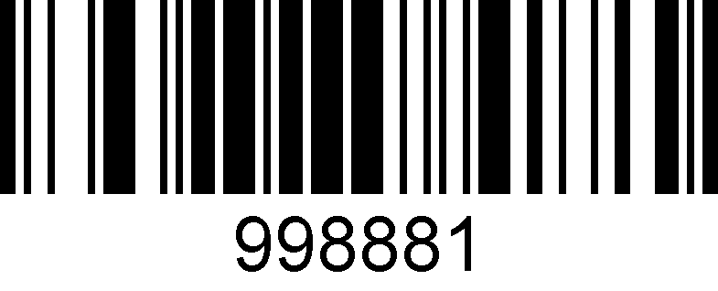

**\*Enable**

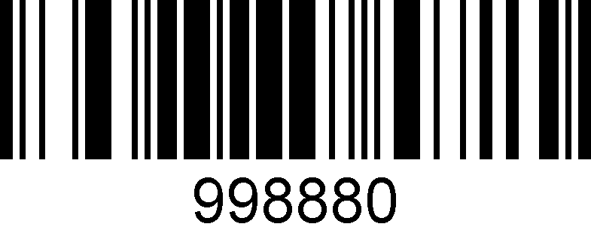

**Disable**

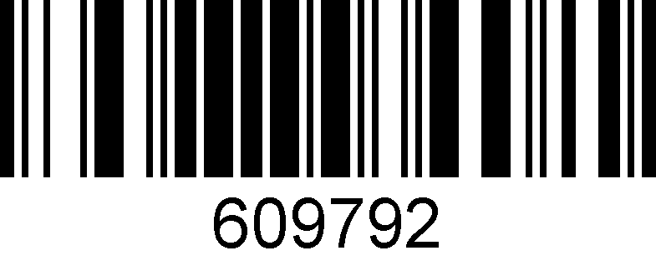

**Check bits on**

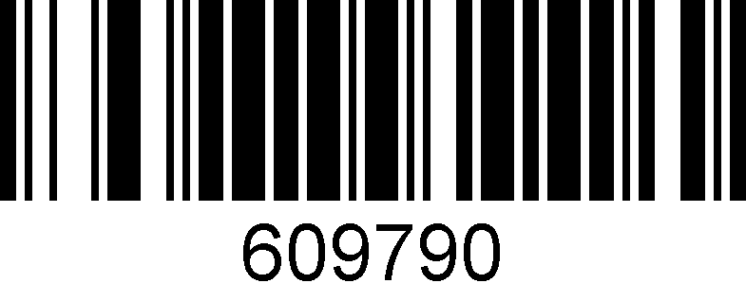

**\*No check bit**

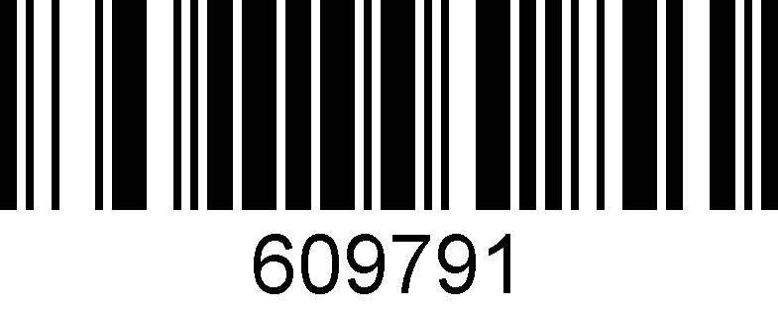

**Check bits on and output**

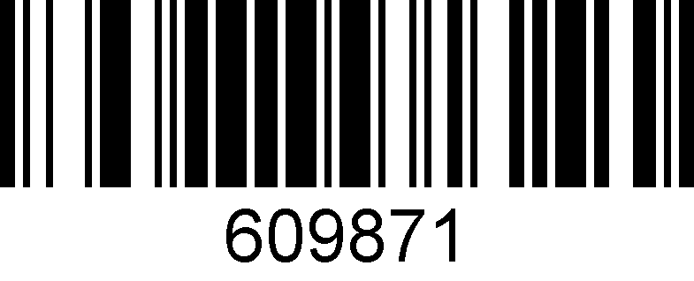

**Initial and ending bit output**

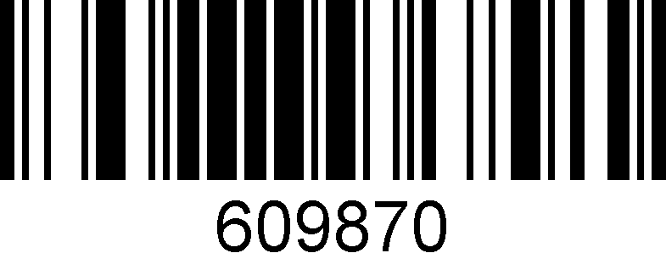

**\*Initial and ending bit output off**

### 10. Code93

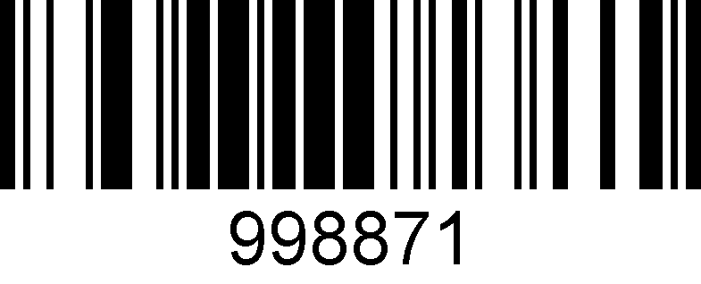

**Enable**

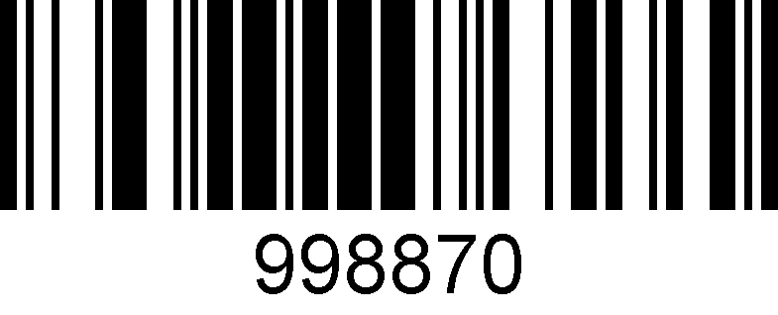

**\*Disable**

### 11.Composite

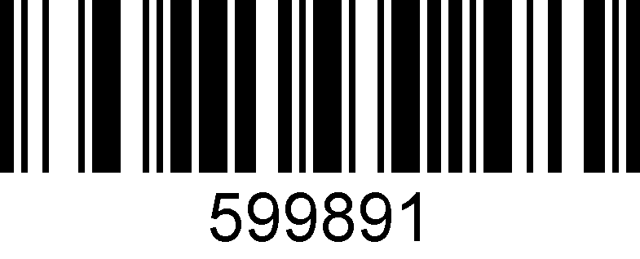

**Enable**

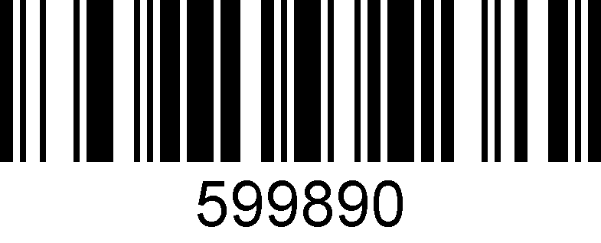

**\*Disable**

### 12. Data Matrix Code

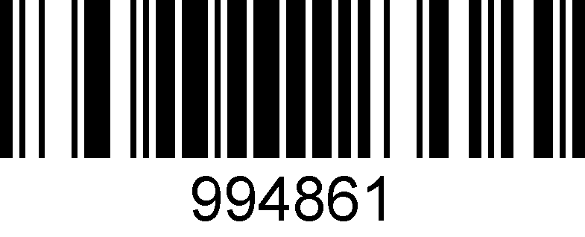

**\*Enable**

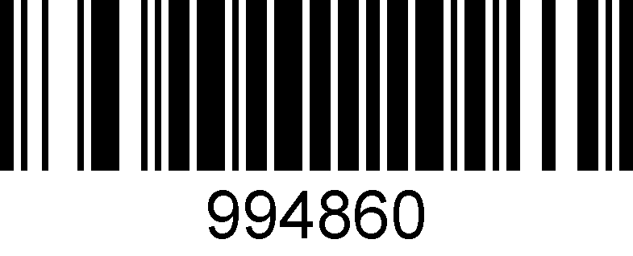

**Disable**

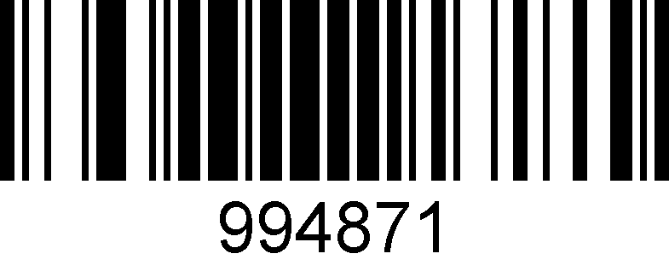

**Black & white reversed DM code enable**

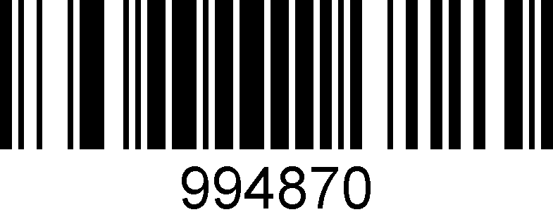

**\* Black & white reversed DM code disable**

### 13.DOT_CODE

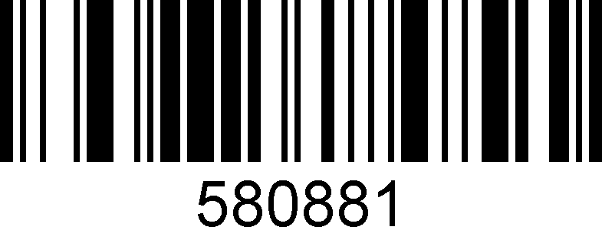

**Enable**

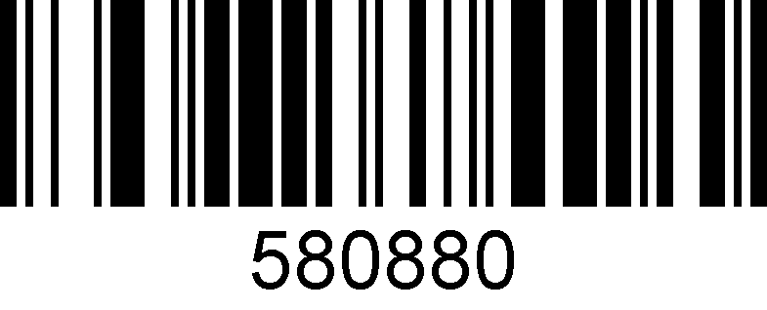

**\*Disable**

### 14. EAN/UPC

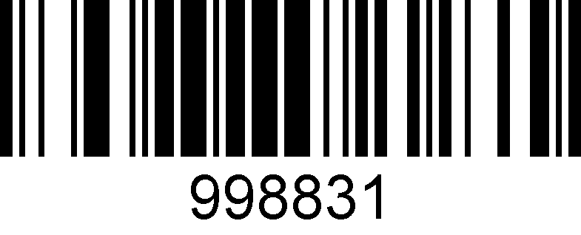

**\*Enable**

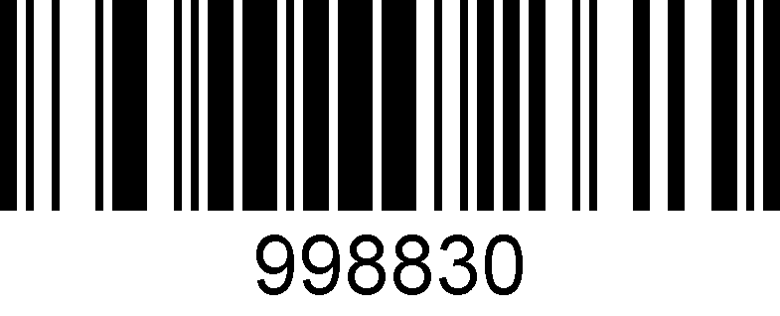

**Disable**

### 15. EAN-8

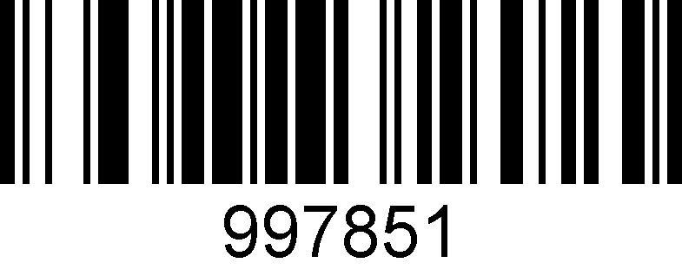

**\*Enable**

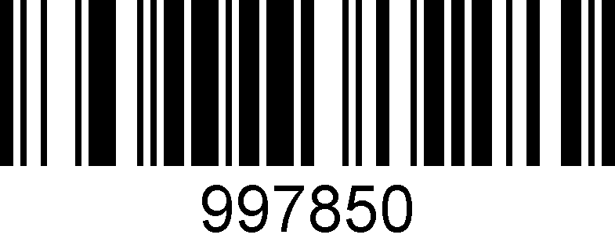

**Disable**

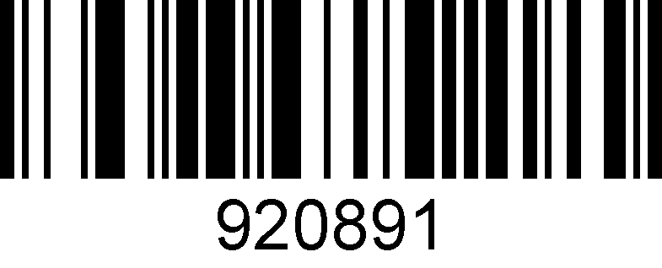

**\* EAN-8 check bit output**

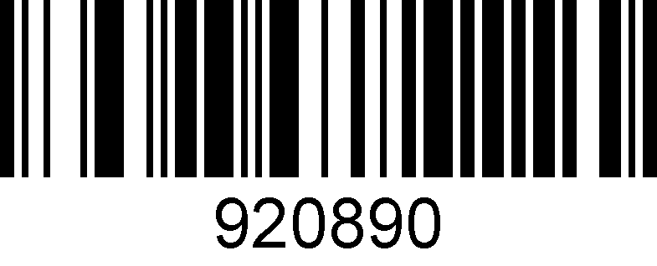

**EAN-8 check bit output off**

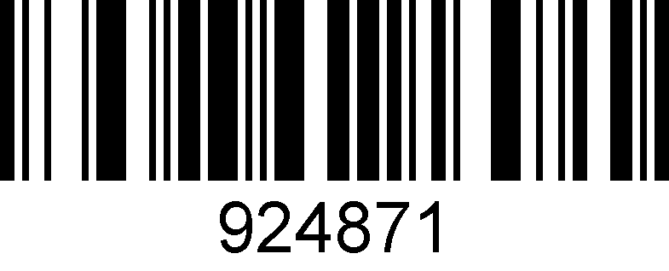

**EAN-8 transform to EAN-13**

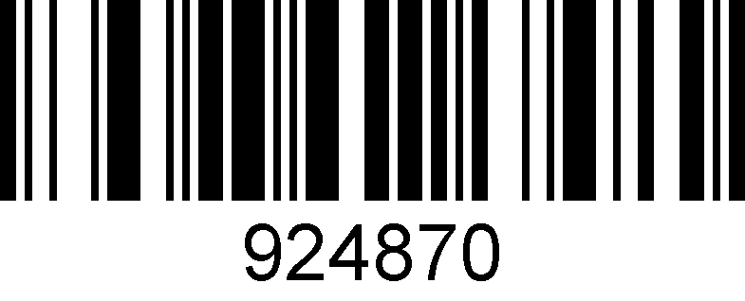

**\* EAN-8 transform to EAN-13 disable**

### 16. EAN-13

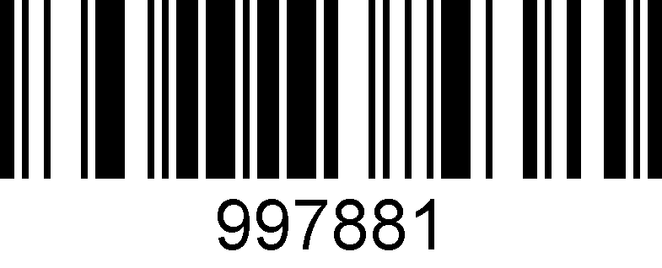

**\*Enable**

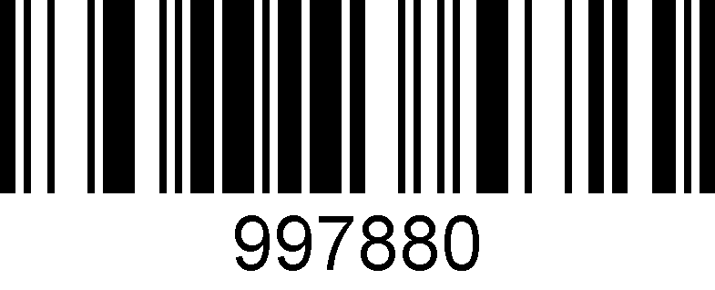

**Disable**

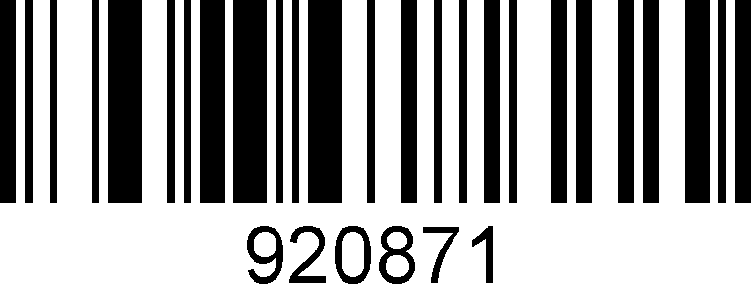

**\* EAN-13 check bit output**

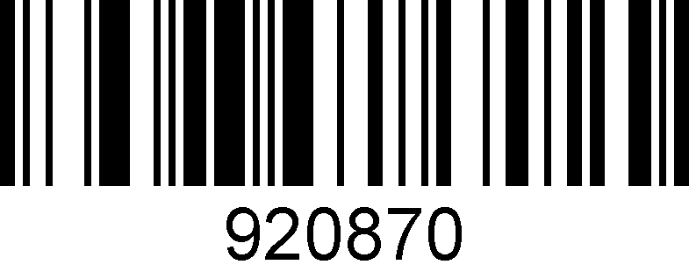

**EAN-13 check bit output off**

### 17. Full ASCII Code39

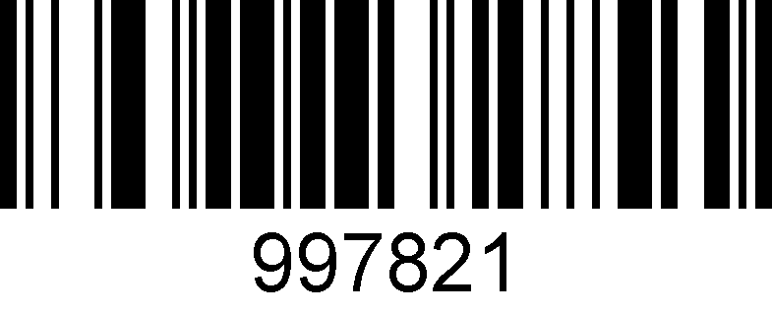

**Enable**

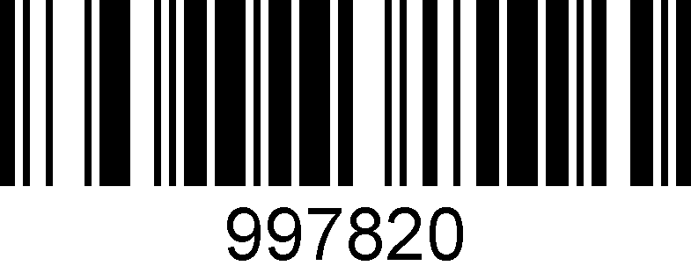

**\*Disable**

### 18. GS1 DataBar Expanded

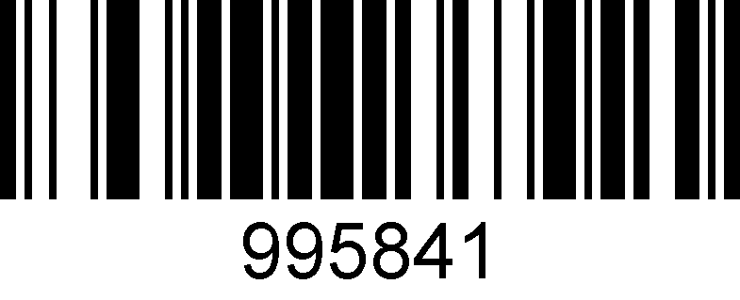

**Enable**

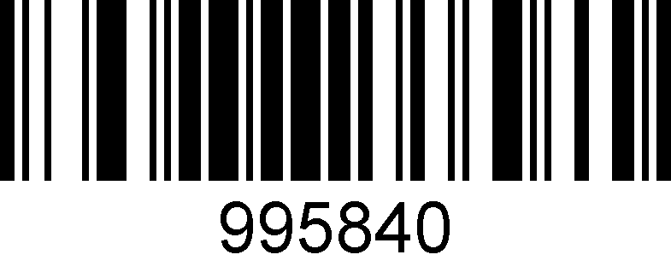

**\*Disable**

### 19. GS1 DataBar Limited

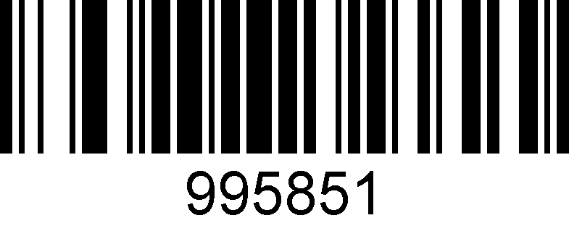

**Enable**

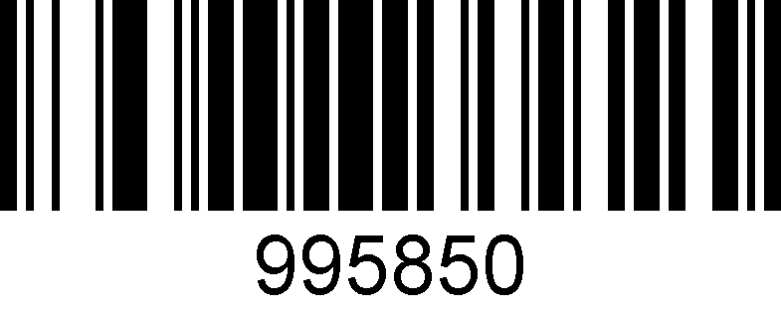

**\*Disable**

### 20. GS1 DataBar Omnidirectional

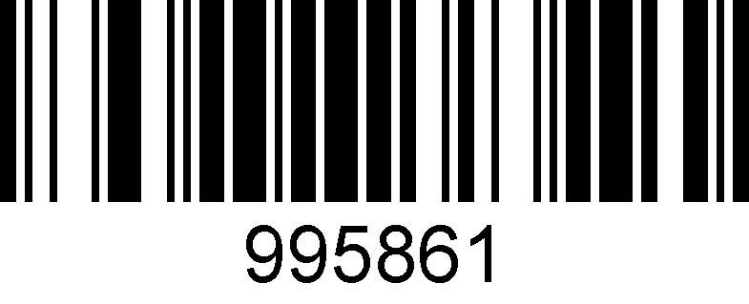

**Enable**

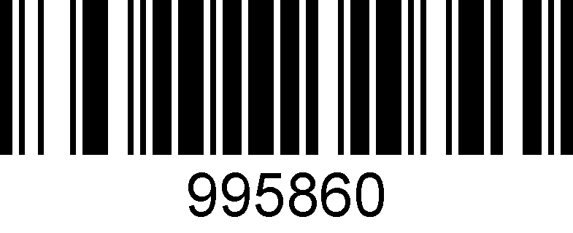

**\*Disable**

### 21. HANXIN

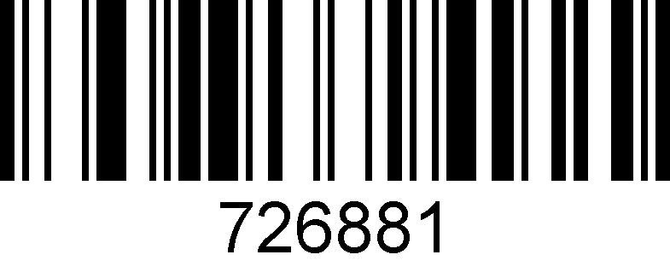

**Enable**

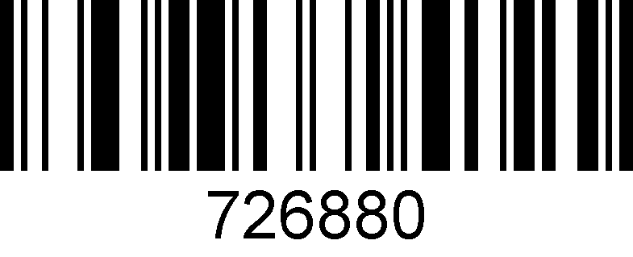

**\*Disable**

### 22. Hong Kong 2 of 5(China post)

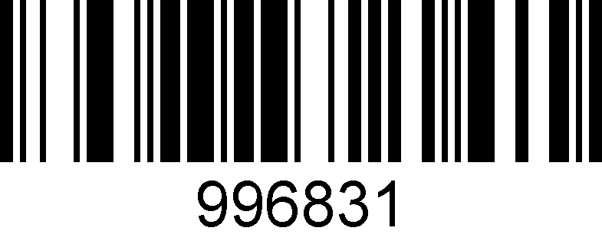

**Enable**

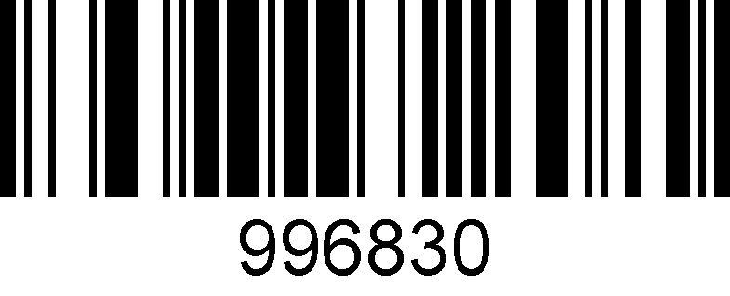

**\*Disable**

**Notice: When reading a postal, all other postal need close.**

### 23. Interleaved 2 of 5

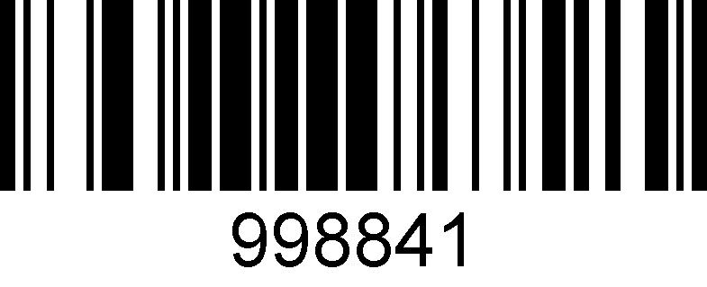

**\*Enable**

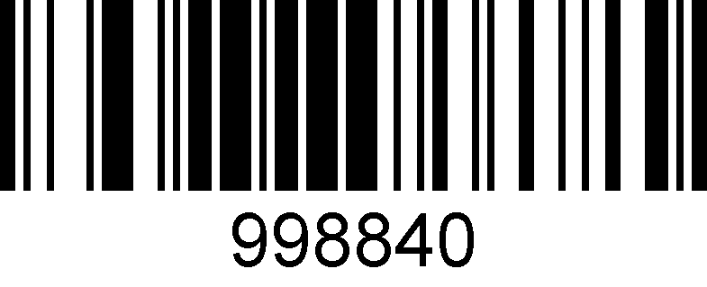

**Disable**

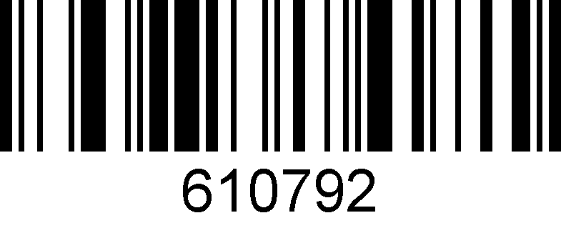

**Check bit on**

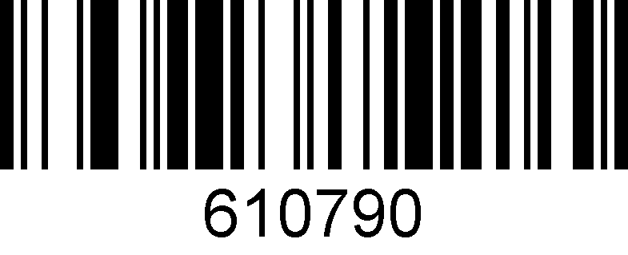

**\*Check bit off**

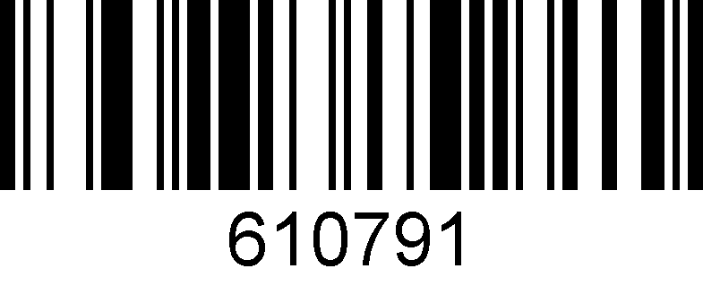

**Check bit on and output**

### 24. Matrix 2 of 5

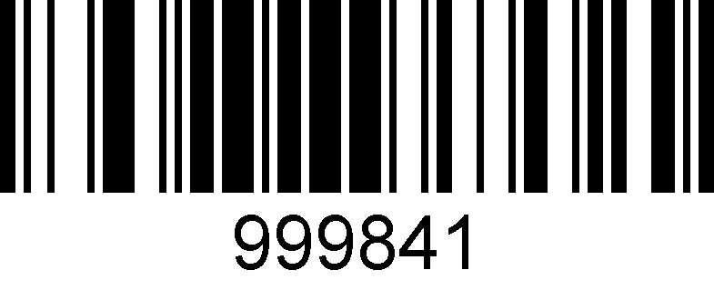

**Enable**

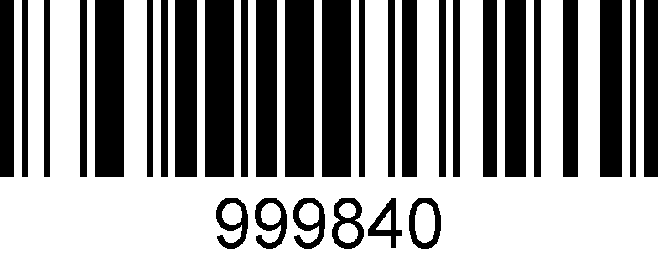

**\*Disable**

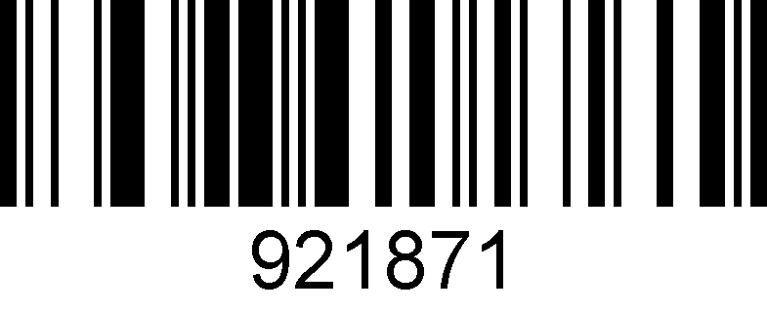

**Matrix 2 of 5 check bit on**

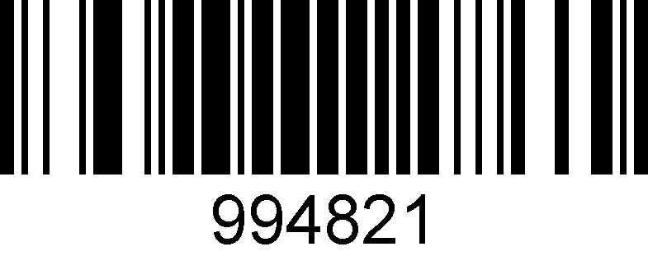

**Matrix 2 of 5 check bit off**



**Matrix 2 of 5 check bit output on**

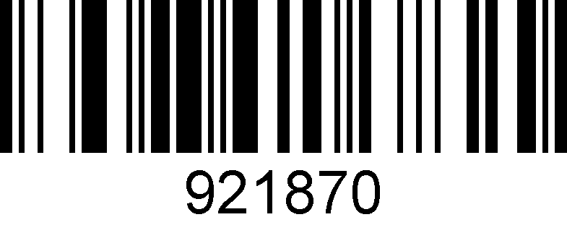

**\* Matrix 2 of 5 check bit output off**

### 25. Maxicode

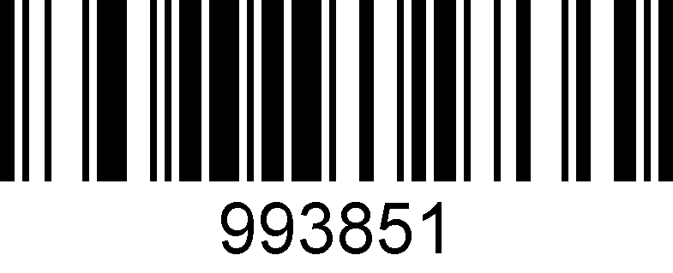

**Enable**

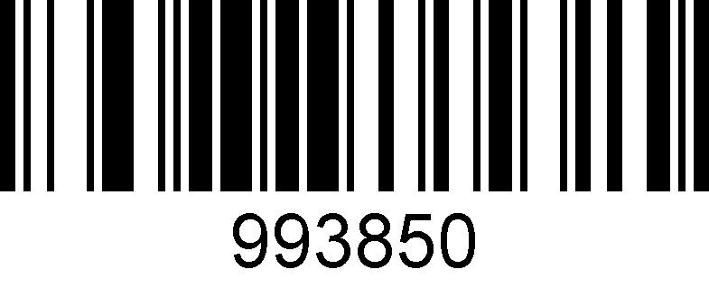

**\*Disable**

### 26. MicroPDF417

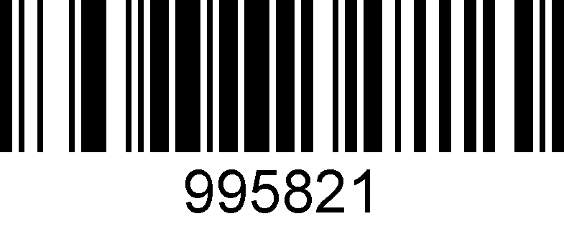

**Enable**

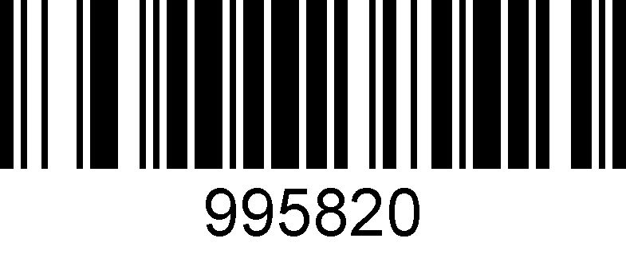

**\*Disable**

### 27. Micro QR Code

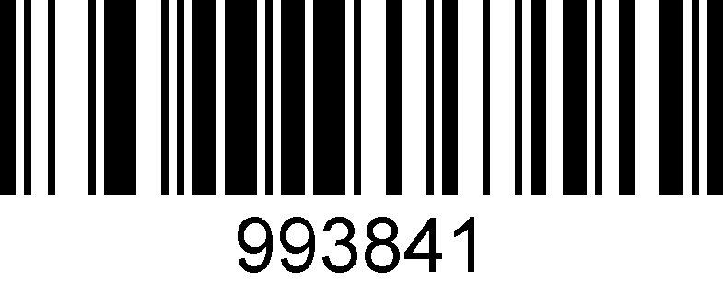

**Enable**

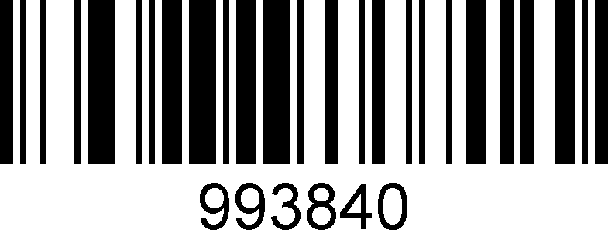

**\*Disable**

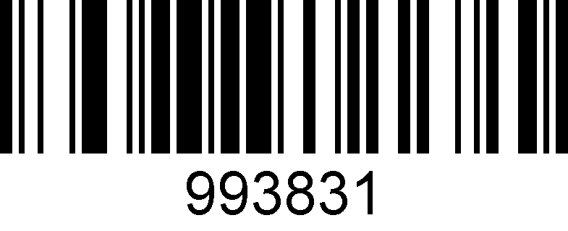

**Black & white reversed micro QR enable**

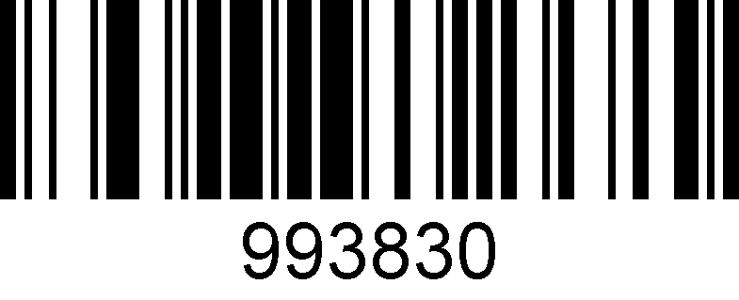

**\* Black & white reversed micro QR disable**

### 28. MSI

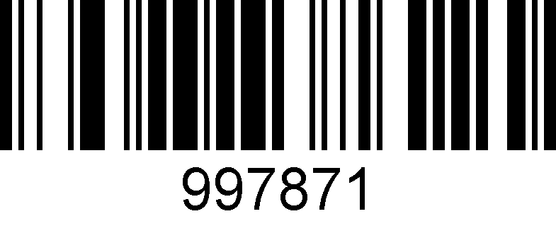

**Enable**

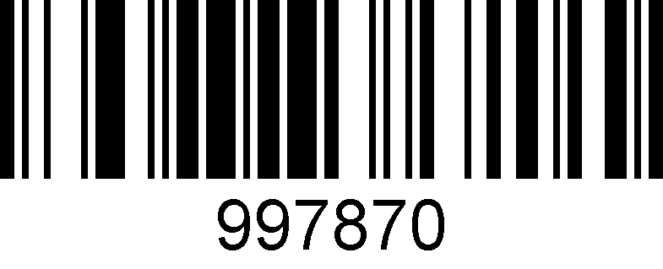

**\*Disable**

### 29. PDF417

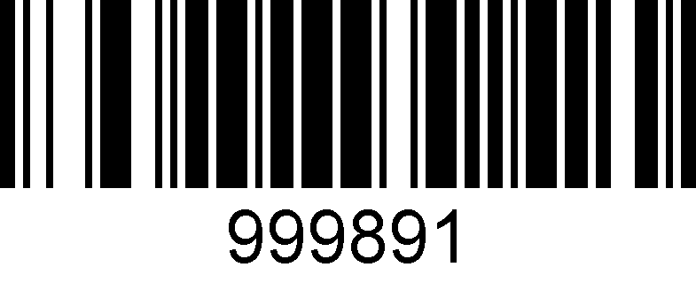

**\*Enable**

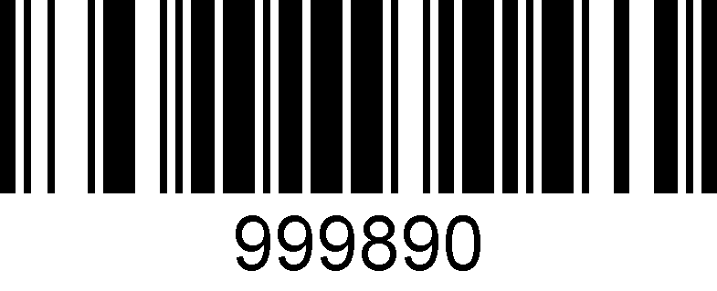

**Disable**

### 30. Pharmacode

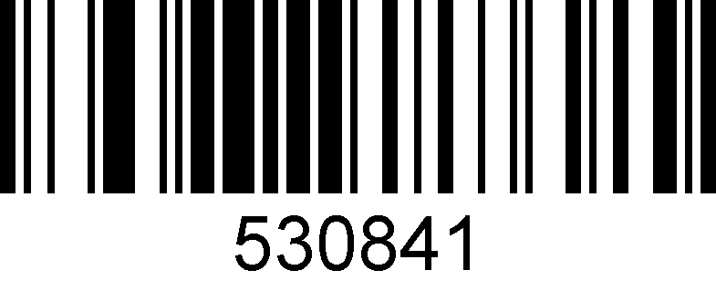

**Enable**

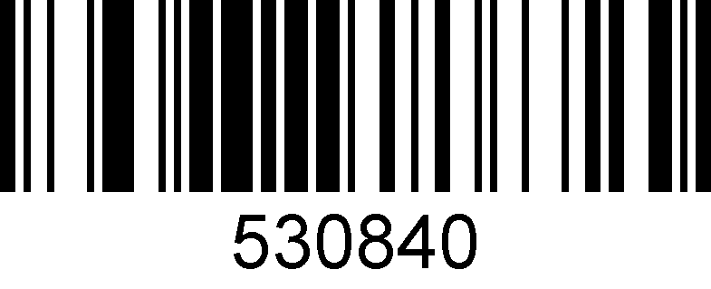

**\*Disable**

### 31. QR Code

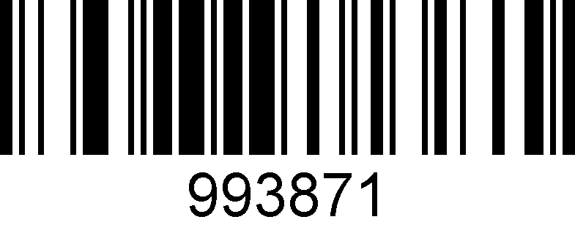

**\*Enable**

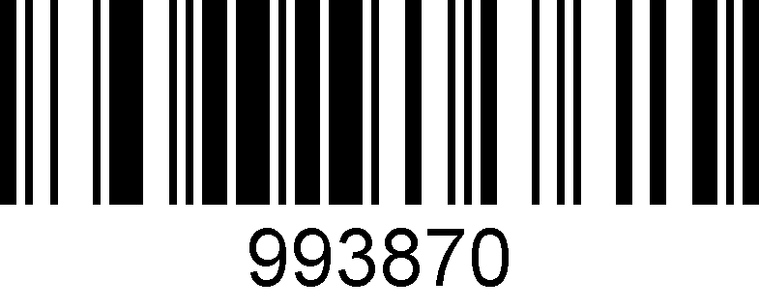

**Disable**

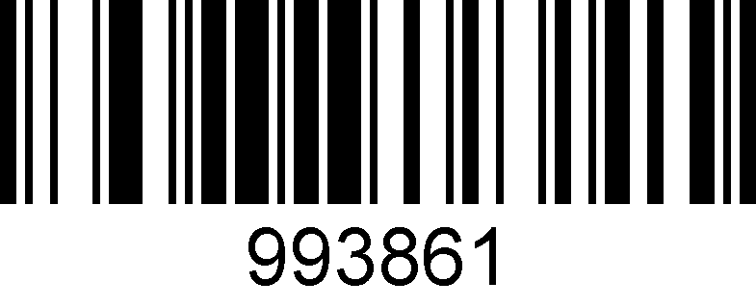

**Black and white reversed QR enable**

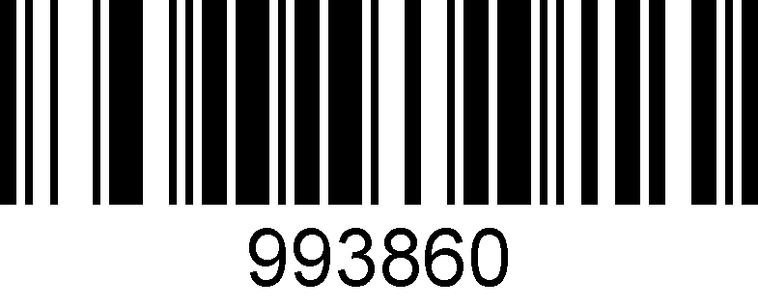

**\* Black and white reversed QR Disable**

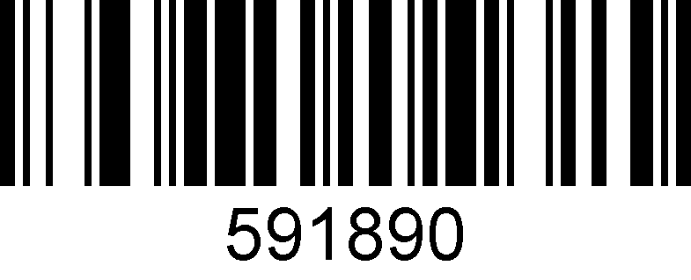

**\*Web site address on**

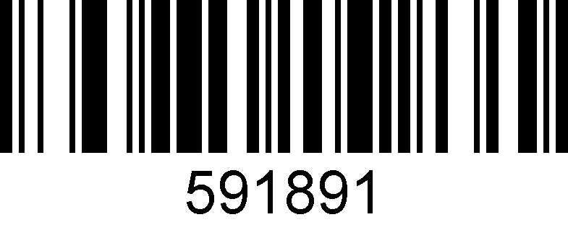

**Web site address off**

### 32. Straight 2 of 5 Industrial

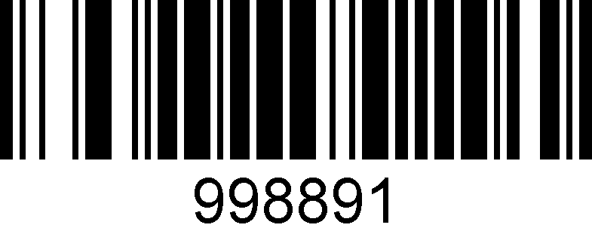

**Enable**

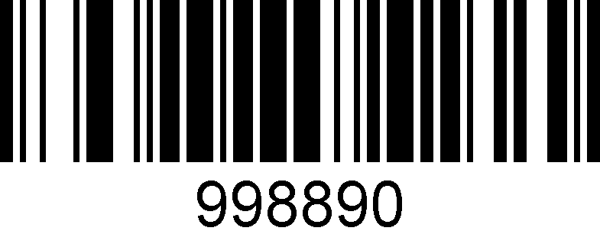

**\*Disable**

### 33. Telepen

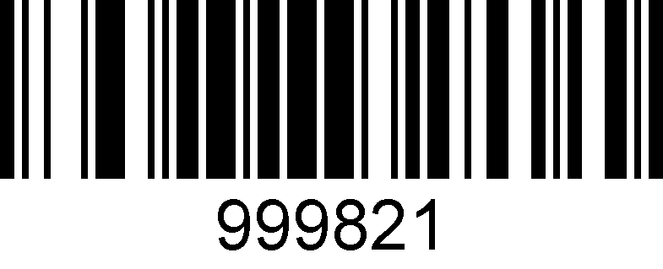

**Enable**

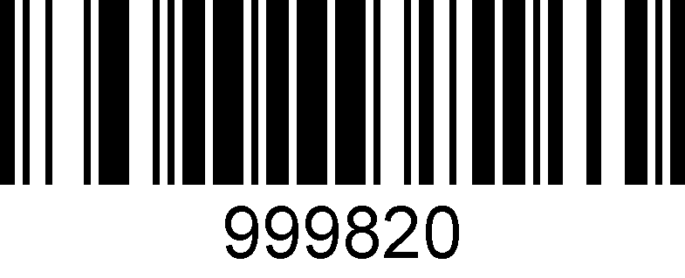

**\*Disable**

### 34. Trioptic Code

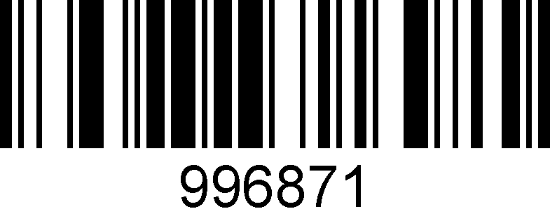

**Enable**

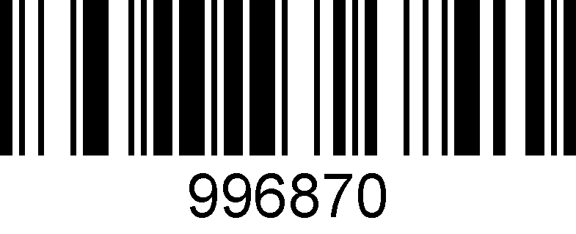

**\*Disable**

### 35. UPC-A

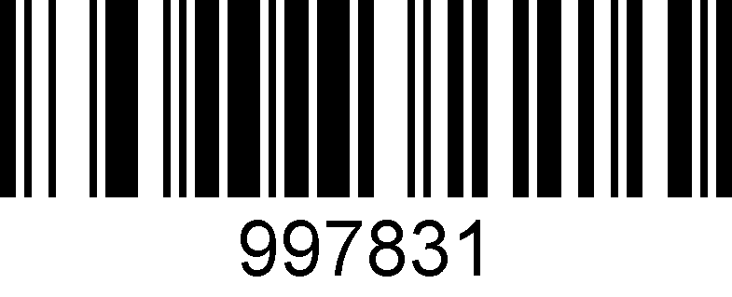

**\*Enable**

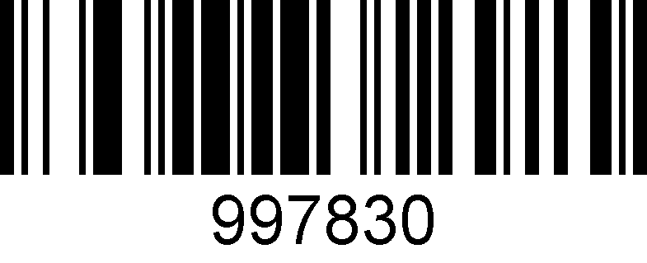

**Disable**

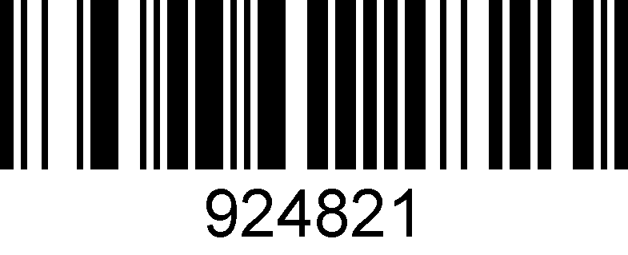

**\*UPC-A check bit output**

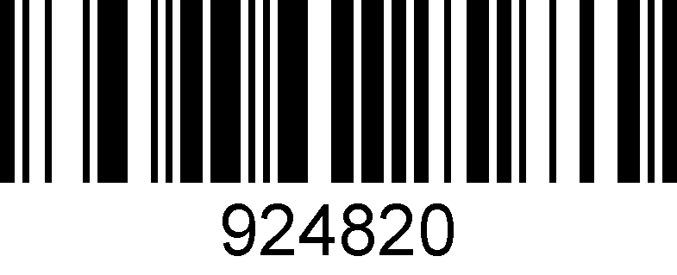

**UPC-A check bit output off**

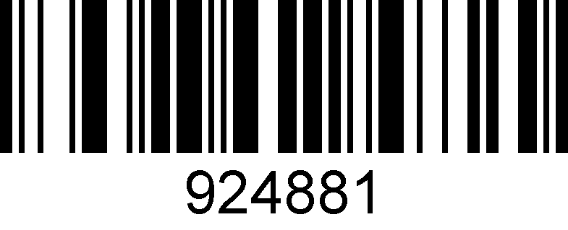

**\*UPC-A number system digit output**

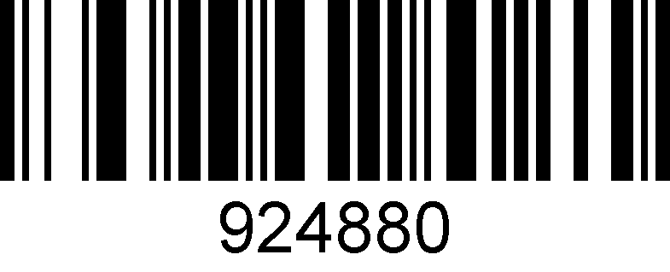

**UPC-A number system digit output off**

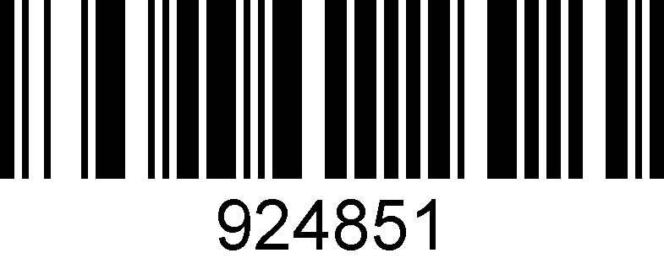

**UPC-A transform to EAN-13**

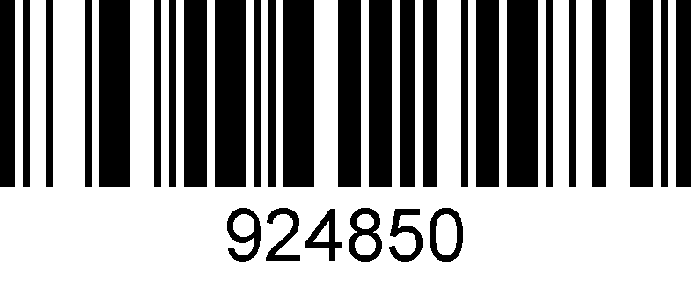

**\*UPC-A transform to EAN-13 off**

### 36. UPC-E

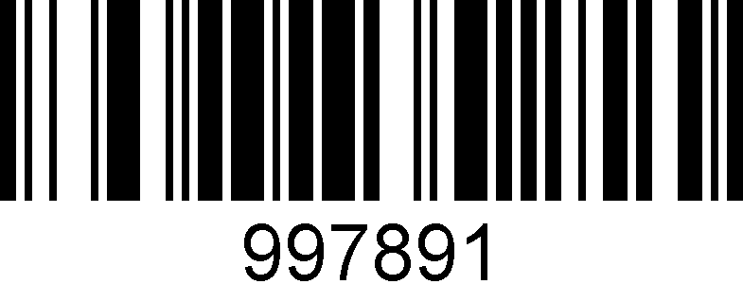

**\*Enable**

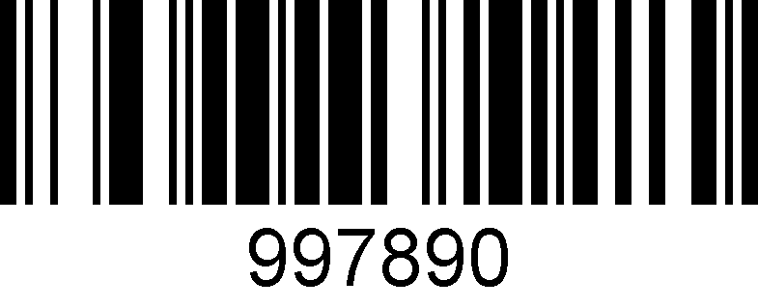

**Disable**

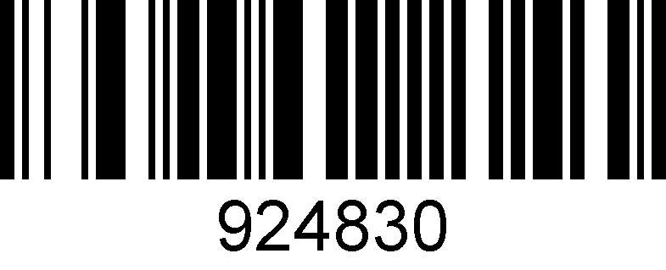

**\*UPC-E check bit output off**

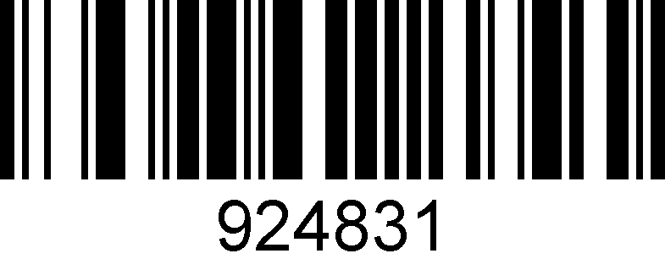

**UPC-E check bit output**

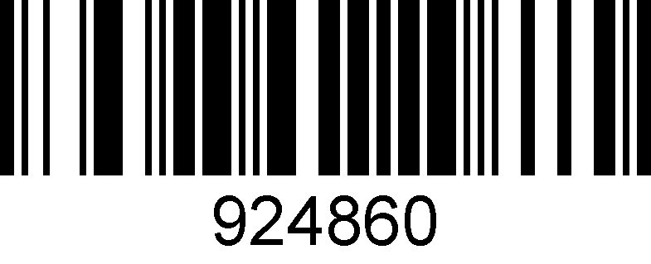

**\*UPC-E head bit output off**

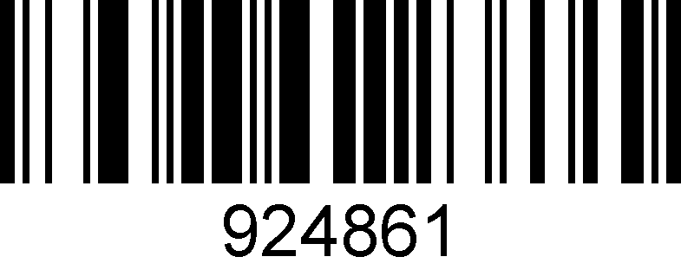

**UPC-E head bit output on**

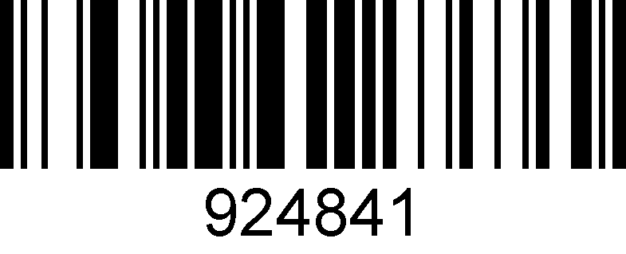

**UPC-E expand to 12 bits**

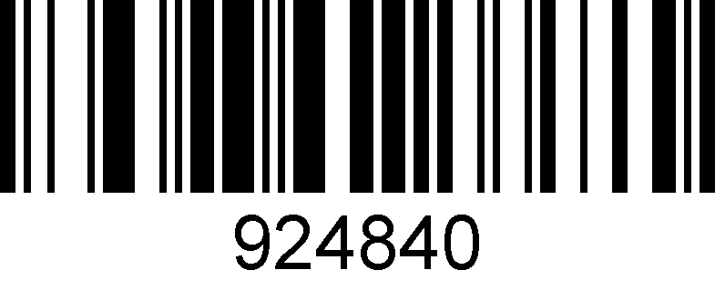

**\* UPC-E expand to 12 bits off**

### 37. UPCE



**Enable**



**\*Disable**

# 5: Special function setting

## About special function setting

This chapter enumerates some configuration examples of equipment use, specifies the configuration method of special functions, which is convenient for users to operate the scanner. The configuration of special functions could be setting by scanning the corresponding configuration barcodes in turn according to the instruction.

## Interleaved 2 of 5 suffix setting

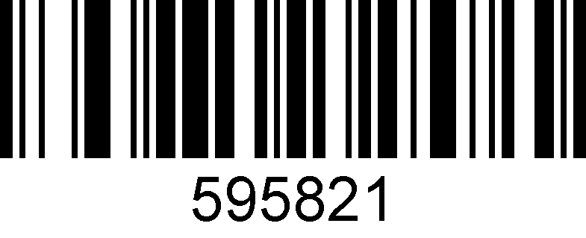

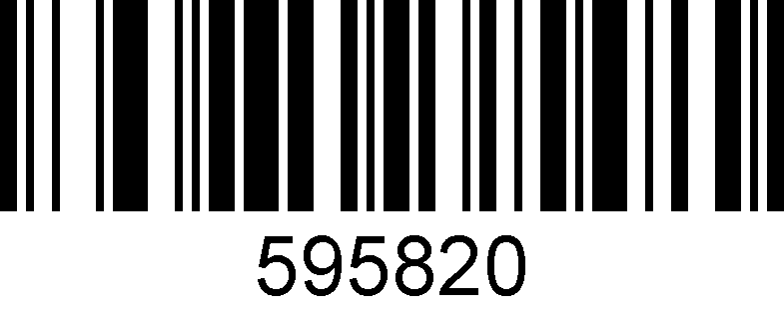

**On**

**Off**

## Invoice information barcode setting

Scan the following configuration barcodes in turn:

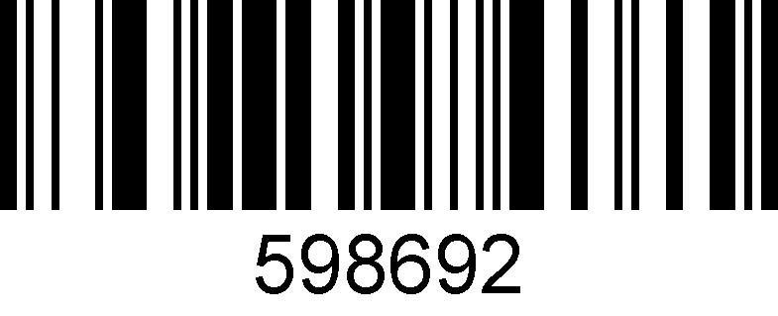

**For MS Notebook and Excel, not for MS Word**

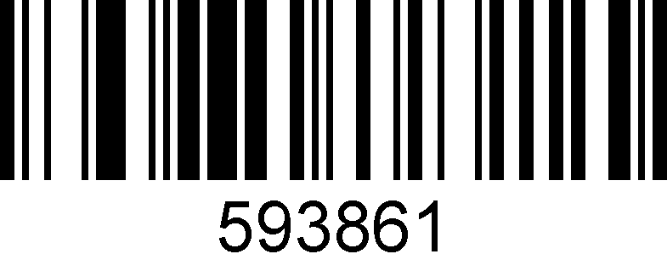

**On**

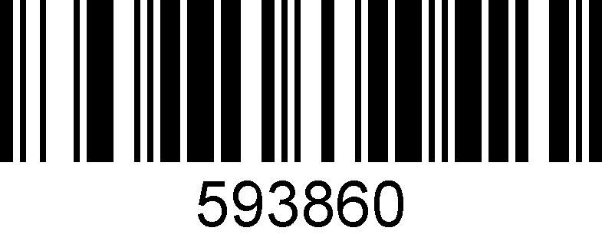

**Off**

## Program mode

## Barcode length locking configuration

**Add a length locking configuration process for a single bar code type:**

Example 1

Lock the code 128 type length to 10 digits. Look-up the barcode types table, the code 128 number is 083.

* 1. Scan the “enter/exit the program mode” setting code, enter the program mode
  2. Scan the “setting the barcode length – type 1” code
  3. Scan the byte code “0”,”1”,”0”in turn
  4. Scan the “setting the barcode types” code
  5. Scan the byte code “0”,”8”,”3”in turn
  6. Scan the “enter/exit the program mode” setting code, exit the program mode

**Add length locking for 2 different barcode types:**

Example 2

1. Scan the “enter/exit the program mode” setting code, enter the program mode
2. Scan the “setting the barcode length – type 1” code for barcode type 1
3. Scan the 3 byte-codes in turn
4. Scan the “setting the barcode types – type 1” code for barcode type 1
5. Scan the 3 byte-codes in turn
6. Scan the “setting the barcode length – type 2” code for barcode type 2
7. Scan the 3 byte-codes in turn
8. Scan the “setting the barcode types – type 2” code for barcode type 2
9. Scan the 3 byte-codes in turn
10. Scan the “enter/exit the program mode” setting code, exit the program mode

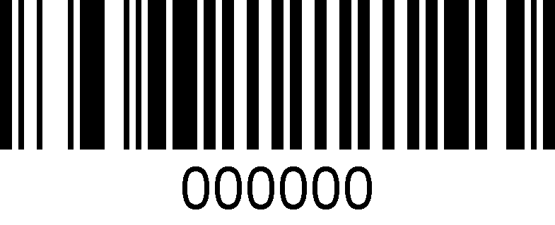

enter/exit the program mode

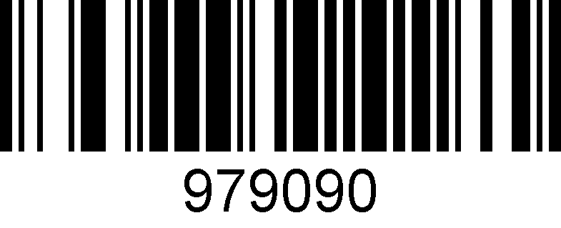

setting the barcode length – type 1

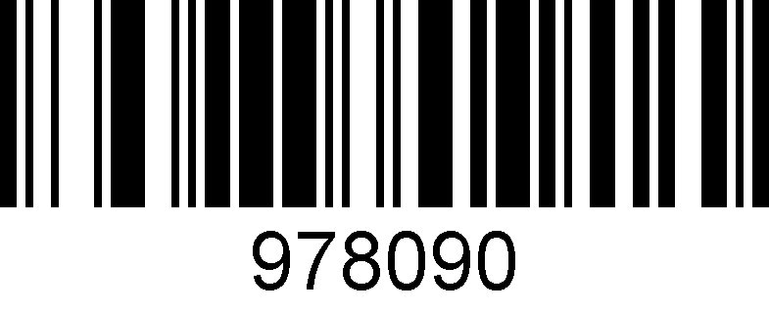

setting the barcode types – type 1

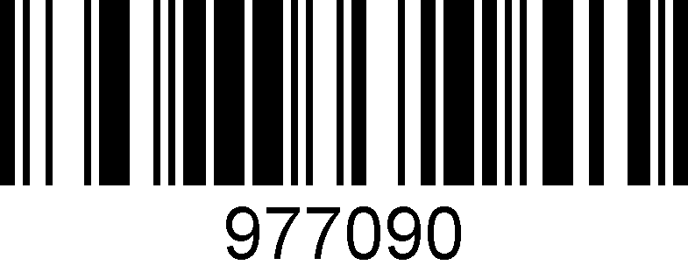

setting the barcode length – type 2

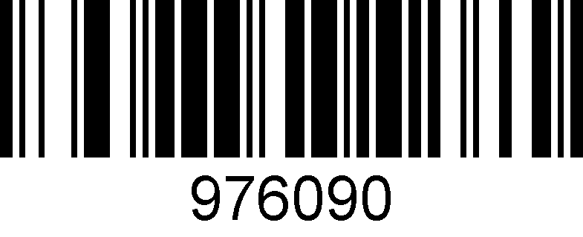

setting the barcode types – type 2

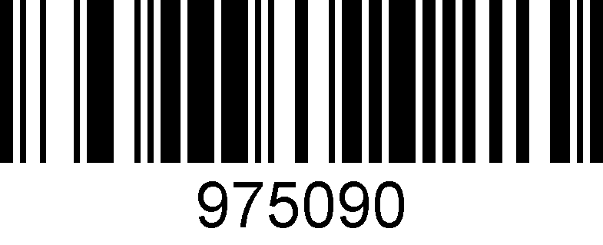

setting the barcode length – type 3

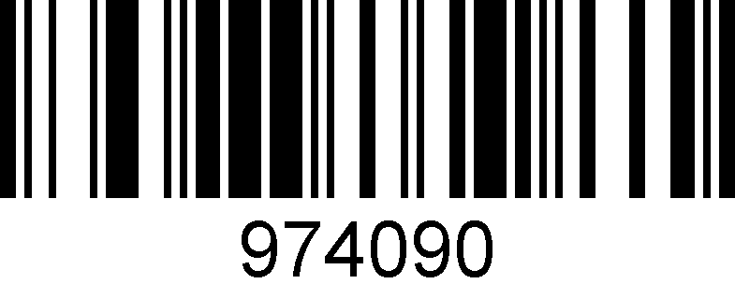

setting the barcode types – type 3

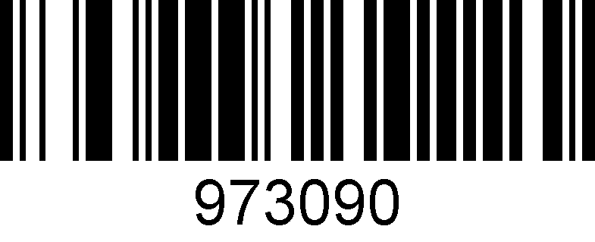

setting the barcode length – type 4

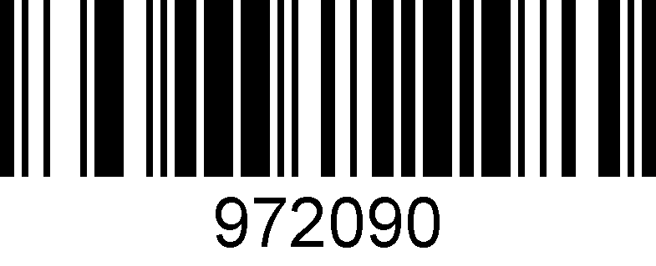

setting the barcode types – type 4

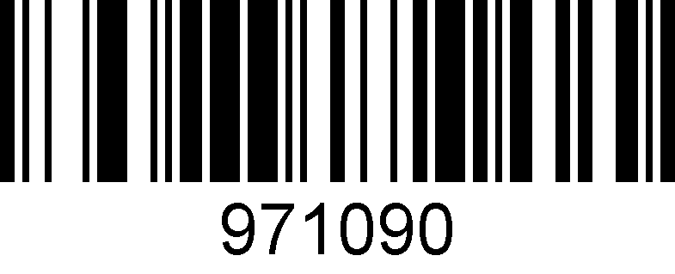

setting the barcode length – type 5

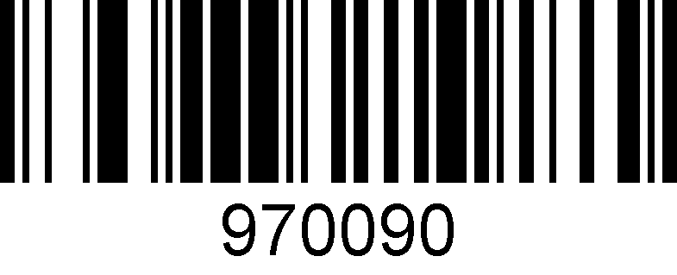

setting the barcode types – type 5

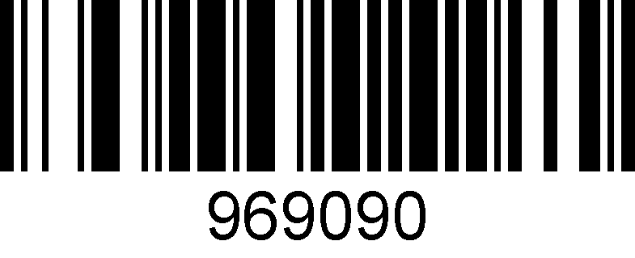

setting the barcode length – type 6

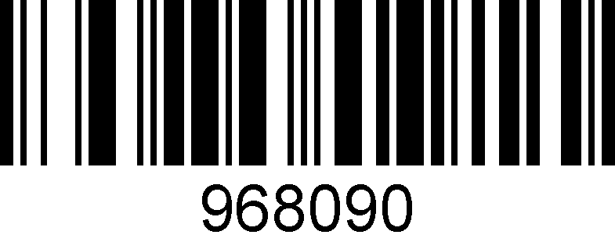

setting the barcode types – type 6

## 

## Byte codes list(decimal)

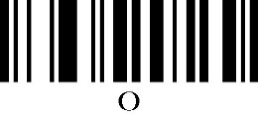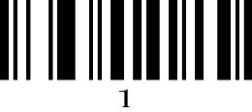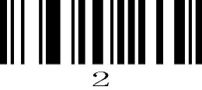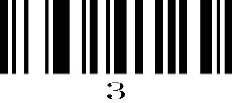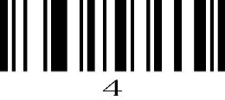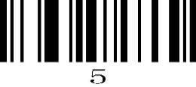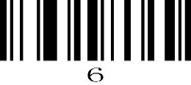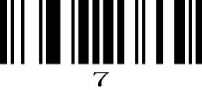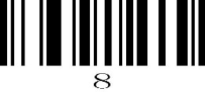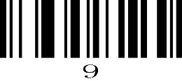

## Barcode Types Table

|  |  |
| --- | --- |
| **Barcode No.** | **Barcode type** |
|  |  |
| **002** | **UPC-E** |
|  |  |
| **003** | **EAN-8** |
|  |  |
| **004** | **UPC-A** |
|  |  |
| **005** | **EAN-13** |
|  |  |
| **080** | **CODE 39** |
|  |  |
| **081** | **CODABAR** |
|  |  |
| **082** | **INTERLEAVED 2 OF 5** |
|  |  |
| **083** | **CODE 128** |
|  |  |
| **084** | **CODE 93** |
|  |  |
| **091** | **MSI** |
|  |  |
| **092** | **CODE 11** |
|  |  |
| **093** | **AIRLINE 2 OF 5** |
|  |  |
| **094** | **MATRIX 2 OF 5** |
|  |  |
| **095** | **TELEPEN** |
|  |  |
| **096** | **UK PLESSEY** |
|  |  |
| **097** | **AIRLINE(13 DIGITS)** |
|  |  |
| **098** | **STANDARD 2 OF 5** |
|  |  |
| **099** | **TRIOPTIC** |
|  |  |
| **101** | **RSS14** |
|  |  |
| **102** | **RSS LIMIT** |
|  |  |
| **103** | **RSS EXT** |
|  |  |
| **104** | **PDF417** |
|  |  |
| **105** | **MICRO PDF417** |
|  |  |
| **106** | **DATA MATRIX** |
|  |  |
| **107** | **AZTEC** |
|  |  |
| **108** | **QR** |
|  |  |
| **109** | **MAXICODE** |
|  |  |

## Add prefix/suffix (maximum 10 characters)

**Process to add prefix:**

Example 1, add a 1-byte prefix and the character is “(”, the ASCII code decimal number is 040.

1. Scan the “enter/exit the program mode” setting code, enter the program mode
2. Scan the “byte 1 prefix setting” barcode
3. Scan the byte-code “0”,”4”,”0”
4. Scan the “enter/exit the program mode” setting code, exit the program mode

**Process to add suffix:**

Example 2, add a 1-byte suffix and the character is “)”, the ASCII code decimal number is 041.

1. Scan the “enter/exit the program mode” setting code, enter the program mode
2. Scan the “byte 1 suffix setting” barcode
3. Scan the byte-code “0”,”4”,”1”
4. Scan the “enter/exit the program mode” setting code, exit the program mode

**Process to add multiple prefix:**

Example 3, add multiple prefix

1. Scan the “enter/exit the program mode” setting code, enter the program mode
2. Scan the “byte 1 prefix setting” barcode
3. Scan the byte-code for the byte 1 prefix
4. Scan the “byte 2 prefix setting” barcode
5. Scan the byte-code for the byte 2 prefix
6. Scan the “enter/exit the program mode” setting code, exit the program mode

**Process to add multiple suffix:**

Similar to add multiple prefix

**Delete all the prefix:**

Scan the “Delete all prefix” setting code

**Delete all the suffix:**

Scan the “Delete all suffix” setting code



**enter/exit the program mode**

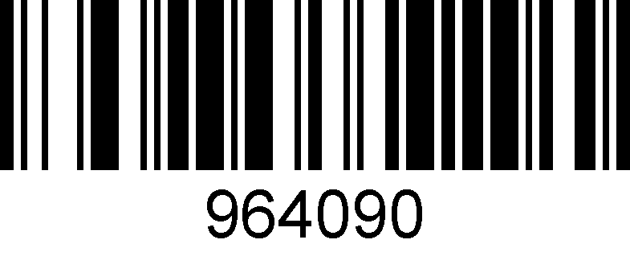

**byte 1 prefix setting**

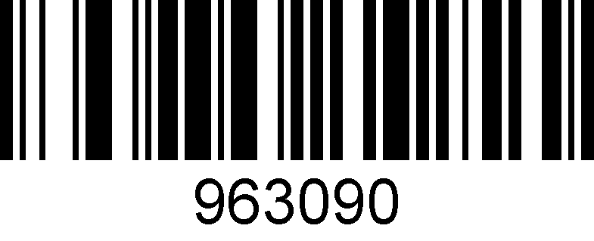

**byte 2 prefix setting**

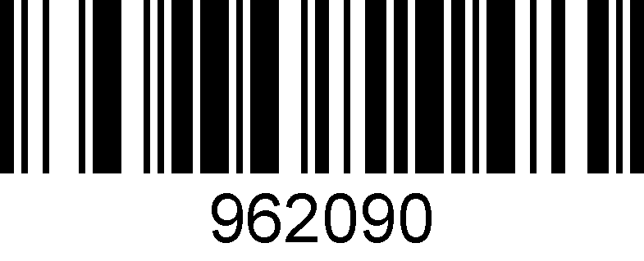

**byte 3 prefix setting**

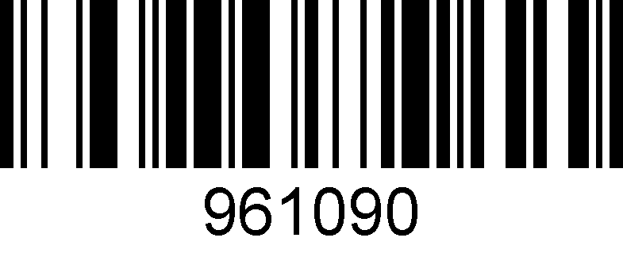

**byte 4 prefix setting**

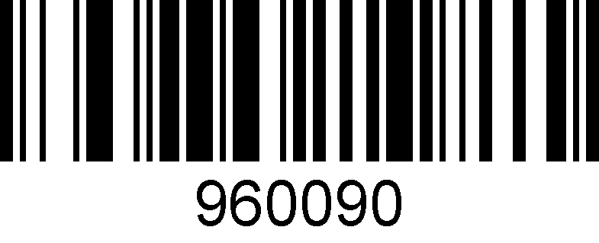

**byte 5 prefix setting**

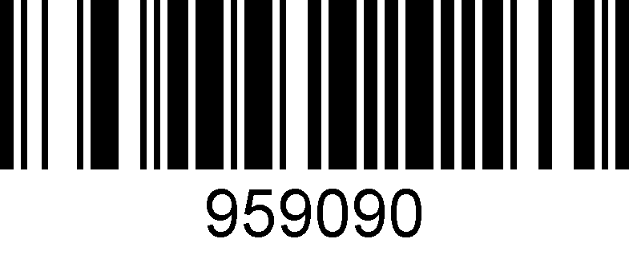

**byte 6 prefix setting**

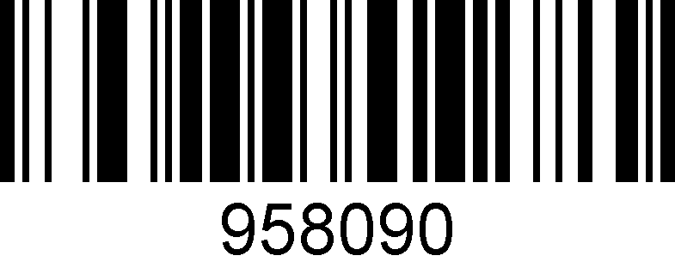

**byte 7 prefix setting**

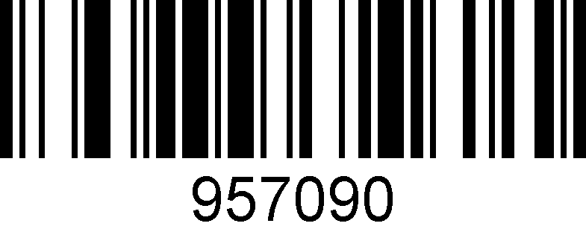

**byte 8 prefix setting**

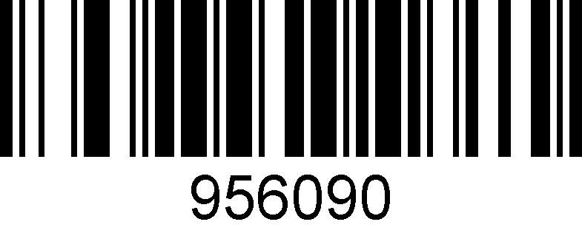

**byte 9 prefix setting**

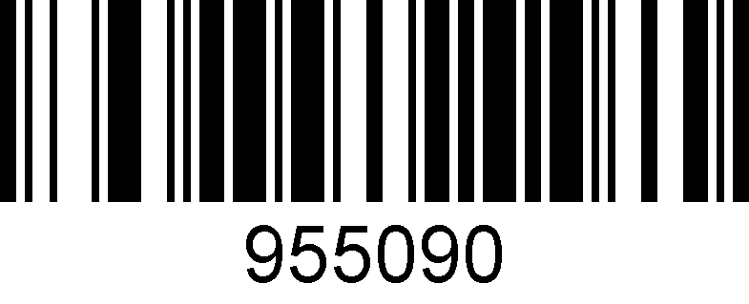

**byte 10 prefix setting**

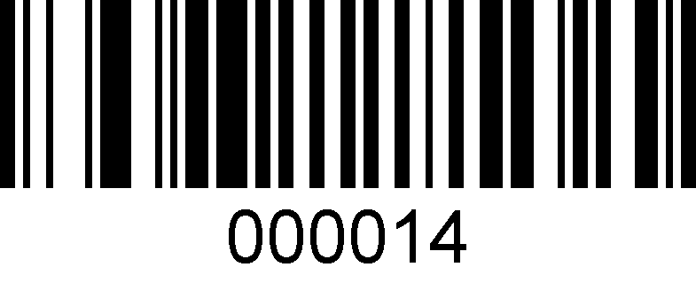

**Delete all prefix**

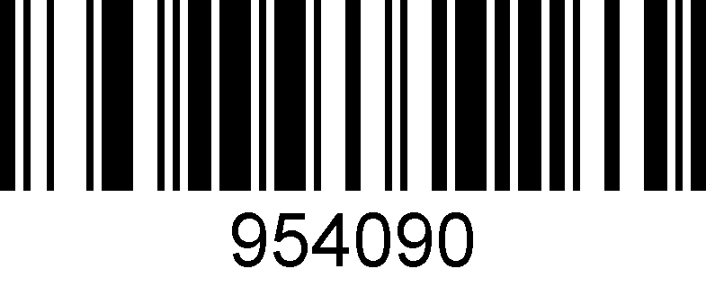

**byte 1 suffix setting**

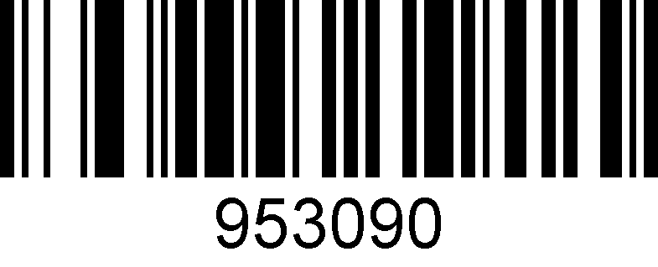

**byte 2 suffix setting**

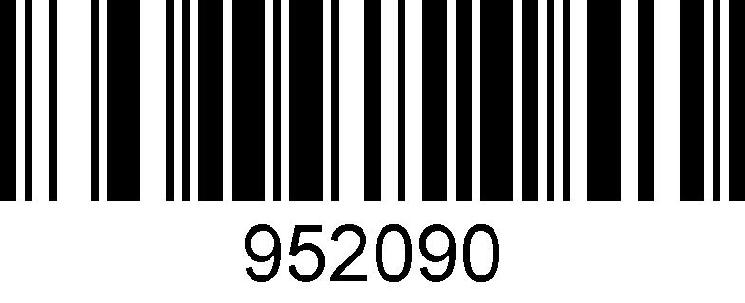

**byte 3 suffix setting**

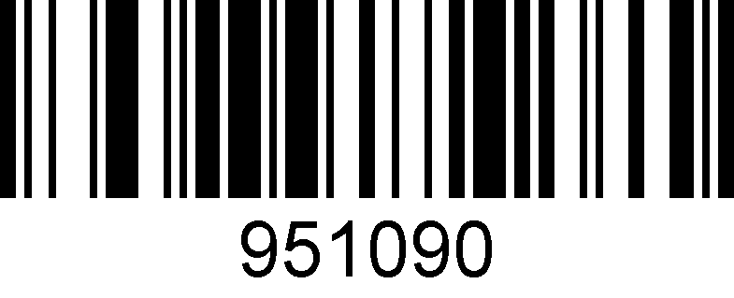

**byte 4 suffix setting**

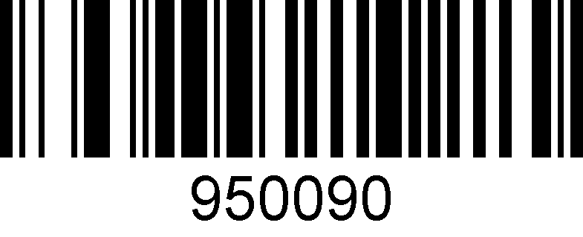

**byte 5 suffix setting**

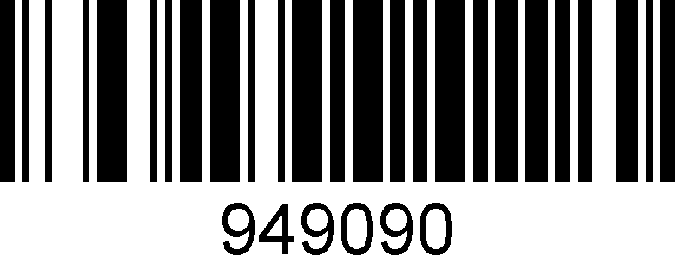

**byte 6 suffix setting**

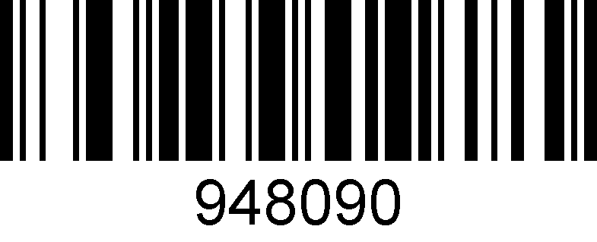

**byte 7 suffix setting**

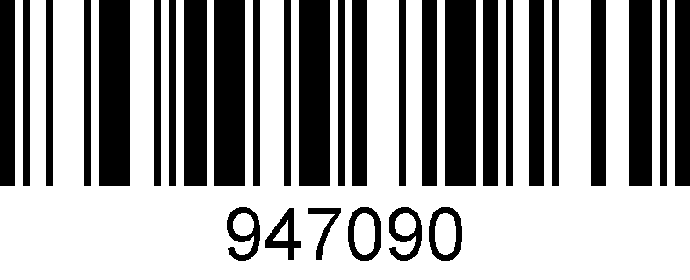

**byte 8 suffix setting**

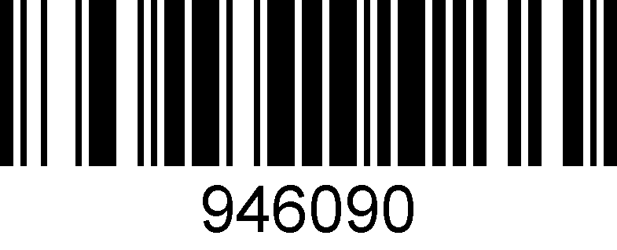

**byte 9 suffix setting**

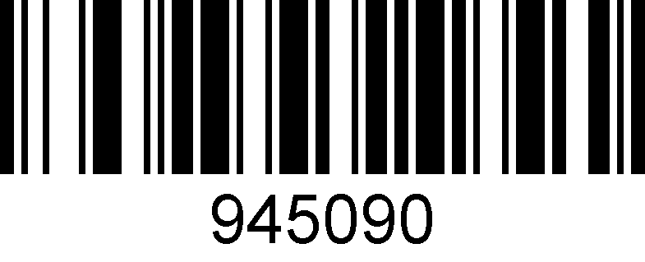

**byte 10 suffix setting**

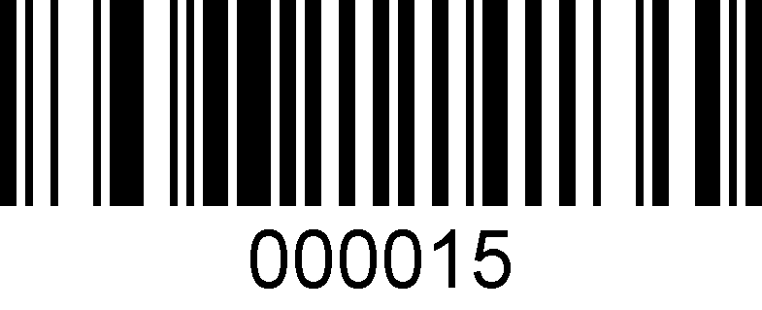

**Delete all suffix**

## Byte codes list(decimal)

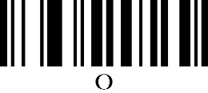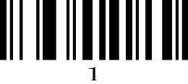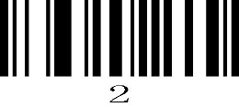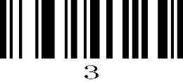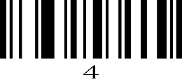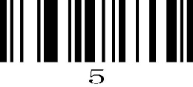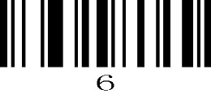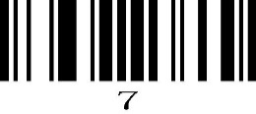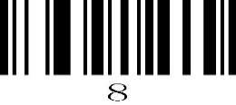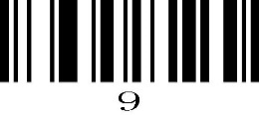

# Appendix: ASCII List

|  |  |  |  |  |  |  |  |
| --- | --- | --- | --- | --- | --- | --- | --- |
| **Decimal number** | **Character** | **Decimal number** | **Character** | **Decimal number** | **Character** | **Decimal number** | **Character** |
| **000** | **NUL** | **032** | **SP** | **064** | **@** | **096** | **‘** |
| **001** | **SOH** | **033** | **!** | **065** | **A** | **097** | **a** |
|  |  |  |  |  |  |  |  |
| **002** | **STX** | **034** | **"** | **066** | **B** | **098** | **b** |
| **003** | **ETX** | **035** | **#** | **067** | **C** | **099** | **c** |
|  |  |  |  |  |  |  |  |
| **004** | **EOT** | **036** | **$** | **068** | **D** | **100** | **d** |
| **005** | **ENQ** | **037** | **%** | **069** | **E** | **101** | **e** |
|  |  |  |  |  |  |  |  |
| **006** | **ACK** | **038** | **&** | **070** | **F** | **102** | **f** |
| **007** | **BEL** | **039** | **`** | **071** | **G** | **103** | **g** |
|  |  |  |  |  |  |  |  |
| **008** | **BS** | **040** | **(** | **072** | **H** | **104** | **h** |
| **009** | **HT** | **041** | **)** | **073** | **I** | **105** | **i** |
|  |  |  |  |  |  |  |  |
| **010** | **LF** | **042** | **\*** | **074** | **J** | **106** | **j** |
| **011** | **VT** | **043** | **+** | **075** | **K** | **107** | **k** |
|  |  |  |  |  |  |  |  |
| **012** | **FF** | **044** | **,** | **076** | **L** | **108** | **l** |
| **013** | **CR** | **045** | **－** | **077** | **M** | **109** | **m** |
|  |  |  |  |  |  |  |  |
| **014** | **SOH** | **046** | **.** | **078** | **N** | **110** | **n** |
| **015** | **SI** | **047** | **/** | **079** | **O** | **111** | **o** |
|  |  |  |  |  |  |  |  |
| **016** | **DLE** | **048** | **0** | **080** | **P** | **112** | **p** |
| **017** | **DC1** | **049** | **1** | **081** | **Q** | **113** | **q** |
|  |  |  |  |  |  |  |  |
| **018** | **DC2** | **050** | **2** | **082** | **R** | **114** | **r** |
| **019** | **DC3** | **051** | **3** | **083** | **S** | **115** | **s** |
|  |  |  |  |  |  |  |  |
| **020** | **DC4** | **052** | **4** | **084** | **T** | **116** | **t** |
| **021** | **NAK** | **053** | **5** | **085** | **U** | **117** | **u** |
|  |  |  |  |  |  |  |  |
| **022** | **SYN** | **054** | **6** | **086** | **V** | **118** | **v** |
| **023** | **ETB** | **055** | **7** | **087** | **W** | **119** | **w** |
|  |  |  |  |  |  |  |  |
| **024** | **CAN** | **056** | **8** | **088** | **X** | **120** | **x** |
| **025** | **EM** | **057** | **9** | **089** | **Y** | **121** | **y** |
|  |  |  |  |  |  |  |  |
| **026** | **SUB** | **058** | **:** | **090** | **Z** | **122** | **z** |
| **027** | **ESC** | **059** | **;** | **091** | **[** | **123** | **{** |
|  |  |  |  |  |  |  |  |
| **028** | **FS** | **060** | **<** | **092** | **\** | **124** | **|** |
| **029** | **GS** | **061** | **=** | **093** | **]** | **125** | **}** |
|  |  |  |  |  |  |  |  |
| **030** | **RS** | **062** | **>** | **094** | **^** | **126** | **~** |
| **031** | **US** | **063** | **?** | **095** | **_** | **127** | **DEL** |
|  |  |  |  |  |  |  |  |
| **ASCII extended (CP-1252 )** | | |  |  |  |  |  |
|  |  |  |  |  |  |  |  |
| **Decimal number** | **Character** | **Decimal number** | **Character** | **Decimal number** | **Character** | **Decimal number** | **Character** |
| **128** | **€** | **160** |  | **192** | **À** | **224** | **à** |
| **129** |  | **161** | **¡** | **193** | **Á** | **225** | **á** |
|  |  |  |  |  |  |  |  |
| **130** | **‚** | **162** | **¢** | **194** | **Â** | **226** | **â** |
| **131** | **ƒ** | **163** | **£** | **195** | **Ã** | **227** | **ã** |
|  |  |  |  |  |  |  |  |
| **132** | **„** | **164** | **¤** | **196** | **Ä** | **228** | **ä** |
| **133** | **…** | **165** | **¥** | **197** | **Å** | **229** | **å** |
|  |  |  |  |  |  |  |  |
| **134** | **†** | **166** | **¦** | **198** | **Æ** | **230** | **æ** |
|  |  |  |  |  |  |  |  |

|  |  |  |  |  |  |  |  |
| --- | --- | --- | --- | --- | --- | --- | --- |
| **135** | **‡** | **167** | **§** | **199** | **Ç** | **231** | **ç** |
|  |  |  |  |  |  |  |  |
| **136** | **ˆ** | **168** | **¨** | **200** | **È** | **232** | **è** |
| **137** | **‰** | **169** | **©** | **201** | **É** | **233** | **é** |
|  |  |  |  |  |  |  |  |
| **138** | **Š** | **170** | **ª** | **202** | **Ê** | **234** | **ê** |
| **139** | **‹** | **171** | **«** | **203** | **Ë** | **235** | **ë** |
|  |  |  |  |  |  |  |  |
| **140** | **Œ** | **172** | **¬** | **204** | **Ì** | **236** | **ì** |
| **141** |  | **173** |  | **205** | **Í** | **237** | **í** |
|  |  |  |  |  |  |  |  |
| **142** | **Ž** | **174** | **®** | **206** | **Î** | **238** | **î** |
| **143** |  | **175** | **¯** | **207** | **Ï** | **239** | **ï** |
|  |  |  |  |  |  |  |  |
| **144** |  | **176** | **°** | **208** | **Ð** | **240** | **ð** |
| **145** | **‘** | **177** | **±** | **209** | **Ñ** | **241** | **ñ** |
|  |  |  |  |  |  |  |  |
| **146** | **’** | **178** | **²** | **210** | **Ò** | **242** | **ò** |
| **147** | **“** | **179** | **³** | **211** | **Ó** | **243** | **ó** |
|  |  |  |  |  |  |  |  |
| **148** | **”** | **180** | **´** | **212** | **Ô** | **244** | **ô** |
| **149** | **·** | **181** | **µ** | **213** | **Õ** | **245** | **õ** |
|  |  |  |  |  |  |  |  |
| **150** | **–** | **182** | **¶** | **214** | **Ö** | **246** | **ö** |
| **151** | **—** | **183** | **·** | **215** | **×** | **247** | **÷** |
|  |  |  |  |  |  |  |  |
| **152** | **˜** | **184** | **¸** | **216** | **Ø** | **248** | **ø** |
| **153** | **™** | **185** | **¹** | **217** | **Ù** | **249** | **ù** |
|  |  |  |  |  |  |  |  |
| **154** | **š** | **186** | **º** | **218** | **Ú** | **250** | **ú** |
| **155** | **›** | **187** | **»** | **219** | **Û** | **251** | **û** |
|  |  |  |  |  |  |  |  |
| **156** | **œ** | **188** | **¼** | **220** | **Ü** | **252** | **ü** |
| **157** |  | **189** | **½** | **221** | **Ý** | **253** | **ý** |
|  |  |  |  |  |  |  |  |
| **158** | **ž** | **190** | **¾** | **222** | **Þ** | **254** | **þ** |
| **159** | **Ÿ** | **191** | **¿** | **223** | **ß** | **255** | **ÿ** |
|  |  |  |  |  |  |  |  |